West Yorkshire Fire & Rescue Service
  - Job Description.
Post Title: Organisational Learning Officer – Service Improvement and Assurance Team (SIAT)
Grade: Grade 6
Responsible To: Service Improvement and Assurance Team (SIAT) Manager
Purpose Of Post: To drive change and learning in line with guidelines and frameworks, supporting WYFRS to build and maintain a culture of continuous learning and improvement.

Organisational chart.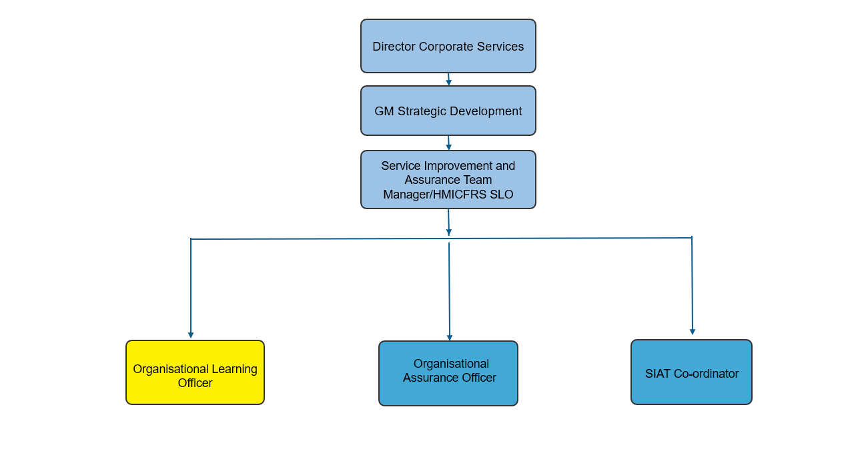Main duties and responsibilities of the role.

- Identifying and Analysing Improvement Opportunities: Use data analysis, stakeholder feedback, and best practice research to pinpoint areas for improvement. Develop dashboards to track performance and identify trends that inform learning and development initiatives.
- Planning and Implementing Change: Create clear action plans with defined steps and responsibilities. Oversee implementation, monitor impact, and adjust as needed to ensure improvements are effective and sustainable.
- Collaborative Learning and Stakeholder Engagement: Work closely with internal and external stakeholders to align improvement efforts with organisational priorities. Support learning opportunities and facilitate knowledge sharing across teams.
- Embedding Continuous Improvement and Organisational Learning: Foster a culture of continuous learning through coaching, facilitation, and regular collaboration. Implement frameworks such as Fire Standards, Fit for Future, and Data Collections to support organisational development.
- Leveraging Technology and Leadership Support: Use technology to collate and analyse data from diverse sources. Work as the services NFCC single point of contact and support national roles, ensuring strategic alignment and leadership continuity.

Organisational wide responsibilities.
- Adherence to the NFCC Core Code of Ethics and West Yorkshire Fire Service Values.
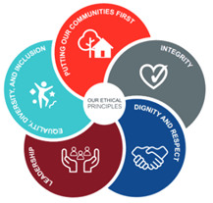
- To implement and promote the Authority’s:
- Health and Safety policies.
- Equality and Diversity policies.
- Information Security Management System policies.
- Safeguarding policies.
- Business continuity policy and contingency arrangements.
- Policies related to General Data Protection Regulation and Data Protection Act 2018.
- Commitment to maintaining our Customer Service expectations.
- A satisfactory Standard Disclosure and Barring check is required for the role.
- This post has been designated a hybrid working post which means the postholder’s working time will be split between the workplace and home. The actual pattern and number of days at each will be agreed locally with the line manager and will be determined based on the service needs.

Skills and experience requirements for this role
In the supporting statement section of the application form give clear, concise examples of how you meet all of the Essential person specification criteria (i.e. items you must be able to do from day one to be able to do the job), identified as ‘Application’ in order to be shortlisted for this vacancy. If a large number of applications are received, only those who also meet the Desirable criteria, identified as ‘Application,’ will be shortlisted, i.e. criteria you need to do the job, but which could be learnt during training.
Please list or number the competency criteria below against which you are providing evidence/examples in order to structure your supporting statement in a well organised way.
There may be some criteria that are identified through ‘Selection Process’ only. You will only be assessed on these criteria during the selection process and not from your application form, this may involve tests, presentations, interview etc.
 | Experience. | Essential/Desirable. | Where identified.
 | Experience of developing and leading internal and external quality assurance processes within a large organisation. | Essential. | Application & Selection Process.
 | Experience of collating, scrutinising, and analysing data. | Essential. | Application & Selection Process.
 | Experience in supporting a large organisation to identify learning and improvement. | Essential. | Application & Selection Process.
 | Experience of working collaboratively with internal and external stakeholders. | Essential. | Application & Selection Process.
 | Experience in developing and delivering organisation wide scrutiny activities. | Desirable. | Application & Selection Process.

 | Education and Training. | Essential/Desirable. | Where identified.
 | Literacy and Numeracy at Level 2 / GCSE Maths and English Grade C or above / equivalent qualifications, or equivalent level of literacy and numeracy gained through work experience. | Essential. | Application & Selection Process.
 | Proficiency in digital tools including Microsoft Office, and collaboration tools (e.g. Teams, SharePoint). | Essential. | Application & Selection Process.
 | Experience of working with Excel and Power Bi to develop dashboards and analyse data in depth. | Desirable. | Application & Selection Process.

 | Special knowledge and skills. | Essential/Desirable. | Where identified.
 | Good organisational skills including the ability to deal with conflicting demands in order to meet deadlines. | Essential. | Application & Selection Process.
 | Strong oral and written communication, presentation and interpersonal skills and the ability to communicate effectively with all levels internally and externally. | Essential. | Application & Selection Process.
 | Demonstrate commitment to good data quality within all areas of work. | Essential. | Selection Process only.
 | Monitor multiple projects and take learning opportunities from them. | Essential. | Application & Selection Process.
 | Demonstrate commitment to and understanding of Equality & Diversity, NFCC Core Code of Ethics and WYFRS values. | Essential. | Selection Process only.
 | Use influencing and negotiation skills to advise stakeholders, including management, towards effective courses of action. | Essential. | Application & Selection Process.
 | Knowledge of national frameworks, sector guidance and assurance processes relating to the Fire and Rescue Service. | Desirable | Application & Selection Process.

Job Description last updated: 24/09/2026.

