West Yorkshire Fire & Rescue Service
  - Job Description
Post Title: Prevention Trainer.
Grade: Grade 5.
Responsible To: Partnerships and Training Manager.
Purpose Of Post: To contribute to the delivery of the Prevention Strategy through the professional design, delivery and evaluation of accessible, inclusive and engaging prevention training programmes for internal colleagues, external partners, community groups and learning establishments, supporting organisational improvement, change and service development.

The postholder will hold end-to-end responsibility for allocated prevention training programme areas, ensuring learning interventions are current, effective, quality assured and aligned to organisational priorities, agreed standards and identified community risk reduction needs.

The role will provide professional expertise in prevention training practice to internal colleagues and external partners, using data, learner feedback and evaluation outcomes to inform continuous improvement and support the development of high-quality face-to-face, digital and blended learning provision, ranging from bite-size digital resources to complex learning programmes.
Organisational chart
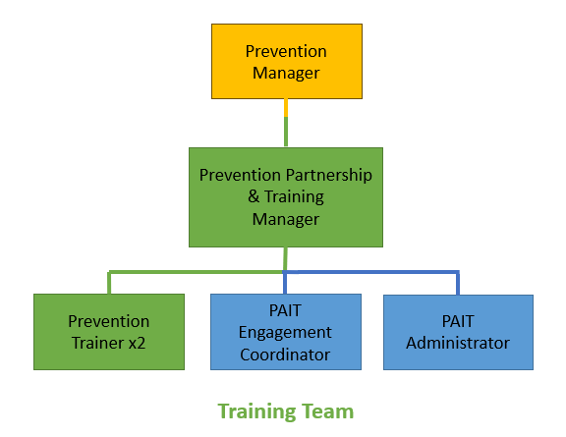

Main duties and responsibilities of the role.
- Lead the end-to-end design, development, delivery evaluation and continuous improvement of high-quality Prevention learning interventions and resources for internal colleagues, external partners, community groups and educational settings, using face-to-face, virtual, digital and blended-learning approaches to support organisational Prevention priorities, ensuring materials remain relevant, accessible, evidence-based and impactful.
- Work collaboratively with internal and external stakeholders to identify learning needs, performance gaps, behaviour change opportunities and risk reduction priorities, building effective relationships to support the development, promotion and implementation of learning initiatives.
- Provide specialist advice and professional support on learning design, training delivery, digital learning platforms, learning technologies, inclusive engagement approaches and Prevention-related development activities, researching and applying emerging methodologies to enhance learner engagement, accessibility and impact.
- Monitor, evaluate and quality assure learning interventions by analysing attendance, learner feedback, engagement data, performance information, outcome measures and producing reports to provide evidence-based recommendations, implementing improvements and remedial actions were required to maintain high standards of delivery and learner experience.
- Maintain accurate learning records, review schedules and resource libraries, ensuring materials, digital content and systems remain relevant, accessible, evidence-based and compliant with organisational policies, quality standards, data protection requirements and relevant legislation.

Organisational wide responsibilities.
- Adherence to the NFCC Core Code of Ethics and West Yorkshire Fire Service Values.
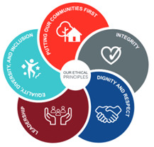
- To implement and promote the Authority’s:
- Health and Safety policies.
- Equality and Diversity policies.
- Information Security Management System policies.
- Safeguarding policies.
- Business continuity policy and contingency arrangements.
- Policies related to General Data Protection Regulation and Data Protection Act 2018.
- Commitment to maintaining our Customer Service expectations.
- A satisfactory Enhanced Disclosure and Barring check is required for the role.
- This post has been designated a hybrid working post which means the postholder’s working time will be split between the workplace and home. The actual pattern and number of days at each will be agreed locally with the line manager and will be determined based on the service needs.

Skills and experience requirements for this role.
In the supporting statement section of the application form give clear, concise examples of how you meet all of the Essential person specification criteria (i.e. items you must be able to do from day one to be able to do the job), identified as ‘Application’ in order to be shortlisted for this vacancy. If a large number of applications are received, only those who also meet the Desirable criteria, identified as ‘Application’, will be shortlisted, i.e. criteria you need to do the job, but which could be learnt during training.
Please list or number the competency criteria below against which you are providing evidence/examples in order to structure your supporting statement in a well organised way.
There may be some criteria that are identified through ‘Selection Process’ only. You will only be assessed on these criteria during the selection process and not from your application form, this may involve tests, presentations, interview etc.
 | Experience. | Essential/Desirable. | Where identified.
 | Demonstrable experience of holding end-to-end responsibility for learning or training programme areas, including identifying learning and development needs through consultation, needs analysis and performance information, and designing, developing, delivering and evaluating high-quality learning solutions for diverse audiences using face-to-face, virtual, digital and blended-learning approaches that deliver measurable outcomes. | Essential. | Application & Selection Process.
 | Experience of creating engaging digital learning resources and programmes, including e-learning, videos, presentations, infographics, toolkits and other multimedia content, ranging from bite-size interventions to larger-scale learning and development initiatives, ensuring materials are current, accessible and suitable for diverse learner needs. | Essential. | Application & Selection Process.
 | Experience of providing specialist advice, guidance and support to managers, colleagues, partners and stakeholders, building effective relationships and influencing the development, coordination, scheduling and delivery of learning, training and organisational development initiatives. | Essential. | Application & Selection Process.
 | Experience of monitoring, evaluating and quality assuring learning interventions, including applying quality assurance frameworks and analysing attendance, feedback, evaluation findings and performance data to produce reports, inform decision-making, measure impact and drive continuous improvement. | Essential. | Application & Selection Process.
 | Experience of managing multiple projects, programme areas, priorities and deadlines whilst maintaining high standards of quality, organisation, version control and attention to detail, and working effectively as part of a team to achieve organisational objectives. | Essential. | Application & Selection Process.
 | Experience of working within a prevention, safeguarding, community safety, education, public sector or emergency services environment, including prevention, safety or community engagement learning activity. | Desirable. | Application & Selection Process.

 | Education and Training. | Essential/Desirable. | Where identified.
 | Good standard of education, evidenced by a degree-level qualification or equivalent knowledge, skills and experience gained through professional development and practical application. | Essential. | Application.
 | A recognised training, teaching or learning and development qualification (e.g. Cert Ed, PGCE, Level 5 Learning and Development or equivalent) | Essential. | Application & Selection Process.
 | Assessor qualification (A1 or equivalent), or a willingness to work towards if not already held. | Essential. | Application & Selection Process.
 | High-level oral, written and presentation skills, with the ability to communicate complex information clearly, influence a range of audiences and develop engaging, accessible learning materials. | Essential. | Application & Selection Process.

 | Special knowledge and skills. | Essential/Desirable. | Where identified.
 | Strong knowledge of learning and instructional design principles, learning methodologies, delivery techniques and learning technologies, with the ability to design, develop and evaluate effective face-to-face, virtual, digital and blended learning solutions and accessible learning resources for diverse audiences. | Essential. | Application & Selection Process.
 | Strong analytical skills, with the ability to interpret learning, evaluation and performance data, identify trends, draw evidence-based conclusions and develop practical solutions that support organisational priorities, behaviour change, risk reduction and performance improvement. | Essential. | Application & Selection Process.
 | Excellent communication, interpersonal, influencing and relationship-management skills, with the ability to explain complex information clearly, adapt communication styles to suit different audiences, and advise, support, negotiate and build credibility with stakeholders at all levels to develop effective partnerships and achieve positive outcomes | Essential. | Application & Selection Process.
 | Excellent organisational and project management skills, with the ability to work with autonomy, manage competing priorities, coordinate activity effectively, deliver high-quality outcomes within agreed timescales and apply feedback, quality assurance findings and performance data to support continuous improvement. | Essential. | Application & Selection Process.
 | Ability to evaluate learning effectiveness and drive continuous improvement through learner feedback, quality assurance processes, performance data and evidence-based practice, applying findings to support continuous improvement and measurable outcomes. | Essential. | Application & Selection Process.
 | Commitment to high standards of data quality, compliance and information governance, ensuring learning records, digital content and evaluation information are accurate, secure, accessible and managed in line with organisational requirements | Essential. | Application & Selection Process.
 | Demonstrates empathy, professionalism and emotional intelligence, together with a commitment to innovation, continuous professional development, data quality, Equality, Diversity and Inclusion, the NFCC Core Code of Ethics and WYFRS Values. | Essential. | Application & Selection Process.
 | Hold and maintain a current full UK driving licence, as the post requires travel & transporting resources between our sites within West Yorkshire. | Essential. | Application & Selection Process.

Job Description last updated: July 2026
Updates: Feb 2019. Wording of JD initially reviewed, and updates commenced at start of a review of JDs and roles by the Prevention Team. Update: Spring 2022 Post titled: Prevention Trainer, post previously titled: Fire Prevention Trainer. Update: July 2024, updated job description template. Update: July 2026, wording reviewed to reflect current focus on digital, virtual and blended learning options.

