West Yorkshire Fire & Rescue Service
  - Job Description.
Post Title Organisational Assurance Officer.
Grade: 5.
Responsible To: Service Improvement and Assurance Team Manager.
Purpose Of Post: To deliver structured assurance, reality testing and evaluation activity to support compliance, continuous improvement and inspection readiness, working within the Service Improvement and Assurance Team alongside the Organisational Learning Officer to promote transparency, accountability and evidence-based improvement aligned to the CRMP, Strategic Action Plan and Fire Standards.

Organisational chart.
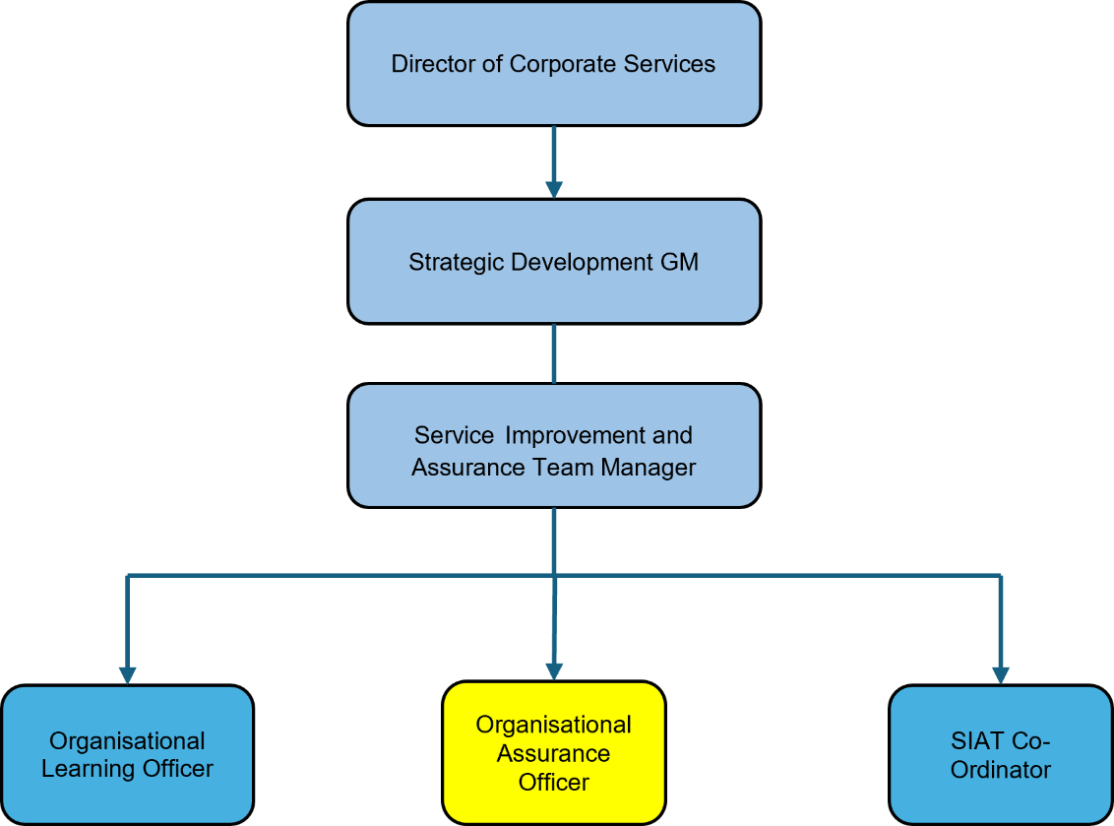

Main duties and responsibilities of the role.
- Deliver organisational assurance through testing, evaluation and benefits tracking, identifying risks and improvement opportunities to support compliance and continuous improvement.
- Coordinate HMICFRS inspection activity, supporting preparation, evidence and follow-up while tracking recommendations and assuring delivery of improvement actions.
- Analyse and report assurance data to identify trends, risks and improvement opportunities, supporting corporate reporting and development of a single source of truth.
- Support organisational learning and continuous improvement by embedding learning from assurance activity, inspections and reviews into improvement plans aligned to CRMP priorities and strategic objectives.
- Support governance, risk and compliance by aligning assurance activity to corporate frameworks, escalating risks appropriately and providing constructive challenge to support sound decision-making.
- Work collaboratively with internal and external stakeholders to coordinate assurance activity, share learning and promote improvement through effective engagement and feedback.

Organisational wide responsibilities.
- Adherence to the NFCC Core Code Of Ethics and West Yorkshire Fire Service Values.

- To implement and promote the Authority’s:
- Health and Safety policies.
- Equality and Diversity policies.
- Information Security Management System policies.
- Safeguarding policies.
- Business continuity policy and contingency arrangements.
- Policies related to General Data Protection Regulation and Data Protection Act 2018.
- Commitment to maintaining our Customer Service expectations.
- A satisfactory Standard Disclosure and Barring check is required for the role.
- This post has been designated a hybrid working post which means the postholder’s working time will be split between the workplace and home. The actual pattern and number of days at each will be agreed locally with the line manager and will be determined based on the service needs.

Skills and experience requirements for this role
In the supporting statement section of the application form give clear, concise examples of how you meet all of the Essential person specification criteria (i.e. items you must be able to do from day one to be able to do the job), identified as ‘Application’ in order to be shortlisted for this vacancy. If a large number of applications are received, only those who also meet the Desirable criteria, identified as ‘Application,’ will be shortlisted, i.e. criteria you need to do the job, but which could be learnt during training.
Please list or number the competency criteria below against which you are providing evidence/examples in order to structure your supporting statement in a well organised way.
There may be some criteria that are identified through ‘Selection Process’ only. You will only be assessed on these criteria during the selection process and not from your application form, this may involve tests, presentations, interview etc.
 | Experience. | Essential/ Desirable. | Where identified.
 | Significant experience and involvement with internal and external quality assurance processes/inspection within a large organisation. | Essential. | Application & Selection Process.
 | Experience of collating, scrutinising analysing, interpreting data. | Essential. | Application & Selection Process.
 | Experience in leading and implementing continuous improvement initiatives using methodologies to enhance service delivery | Essential. | Application & Selection Process.
 | Experience of supporting a large organisation to manage change and realise benefits, to maximise efficient resource management and alignment with strategic objectives. | Essential. | Application & Selection Process.
 | Significant knowledge of Microsoft products and the implementation of ICT solutions to develop processes. | Essential. | Application & Selection Process.
 | Knowledge of governance, risk and improvement frameworks. | Essential. | Application & Selection Process.

 | Education and Training. | Essential/ Desirable. | Where identified.
 | Numeracy and Literacy Level 2/ Maths and English GCSE at Grade C or above, or equivalent level literacy and numeracy gained through work experience. | Essential. | Application & Selection Process.
 | Change and/or Risk Management professional qualification or relevant experience | Desirable. | Application & Selection Process.
 | Level 3 Supervisory and Leadership Apprenticeship or equivalent. | Desirable. | Application & Selection Process.

 | Special knowledge and skills. | Essential/ Desirable. | Where identified.
 | Demonstrable knowledge of capturing benefits realisation within a public sector organisation. | Essential. | Application & Selection Process
 | Knowledge of national frameworks and assurance processes relating to the Fire and Rescue Service. | Essential. | Application & Selection Process.
 | Strong oral and written communication, presentation and interpersonal skills and the ability to communicate effectively with all levels internally and externally. | Essential. | Application & Selection Process.
 | Demonstrate commitment to good data quality within all areas of work. | Essential. | Selection Process only.
 | Demonstrate maintaining confidentiality when dealing with sensitive information. | Essential. | Selection Process only.
 | Excellent influencing and negotiation skills in order to advise and convince stakeholders including Management of most effective course of action. | Essential. | Selection Process only.

Job Description last updated: 15/6/26

