West Yorkshire Fire & Rescue Service
  - Job Description.
Post Title: Operational Policy Coordinator.
Grade: 4.
Responsible To: Group Manager Operational Policy and Guidance.
Purpose Of Post: To support the development, review, maintenance and communication of WYFRS operational policy and guidance, ensuring documents are accurate, accessible, current and aligned to lesgislation, National Operational Guidance, Fire Standards and internal governance requirements.

Organisational chart.

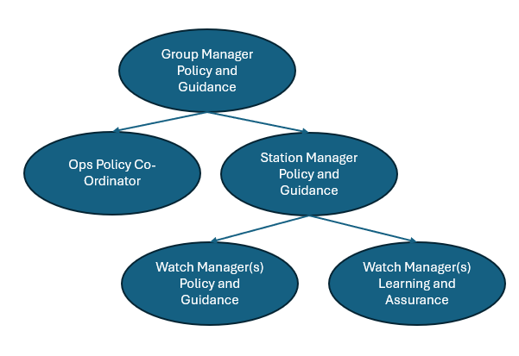

Main duties and responsibilities of the role.

Identify and co-ordinate currency of all WYFRS’ operational Tactical Risk Assessments, policies and guidance in line with review periods.

Determine future operational policy and procedure requirements and support the development of these documents, reflecting legislative and National Operational Guidance requirements.

Review format and content of existing policies and procedures to ensure information is clear and fit for purpose in line with the Service accessibility toolkit.

Support consultation meetings, working effectively with other departments to ensure accurate policy and guidance development.

Maintain and update the InfoHub/OpsHub sites with new/revised information.

Develop and deliver the associated training packages for policy, guidance and product pack as per the responsibility of the Operational Policy department.

Liaise with subject matter experts (SME) to assure content of work and produce in line with the SME direction.

To receive and action requests from internal departments and/or external agencies with regards to operational policy (NFCC, HMICFRS, SIAT etc.).

Lead the administration of 13/16 arrangements ensuring annual financial figure produced.

To support the closure of NOG strategic gaps through research and collaboration with SMEs.

Manage the administration of policy consultation arrangements.

Liaise with and record the findings of policy consultations.

To provide project support to the Service Support directorate.

Attend meetings and capture minutes related to Policy, Learning and Assurance supporting shared work development.

Create and implement effective plans in line with FRS policy objectives.

Develop self, individuals, teams to improve the FRS operational effectiveness.

To maintain and audit the Operations directorate electronic data storage systems in accordance with information security requirements.

To organise and administer departmental meetings, seminars and other operational related events.

To maintain department records and ensure that any data so produced as part of their responsibilities is accurate and current.

To support and assist Auditors and other internal departments with access to information and data where required.

Participate in any relevant training activities as directed by the Operational Policy Group Manager.

Develop OPID/TPID and CPID information as instructed by the Operational Policy Group Manager.

To carry out any research as deemed necessary and appropriate by Officers in the Service Support Directorate.
- To undertake any other duties commensurate with the grade of the post as directed by management.

Organisational wide responsibilities.
- Adherence to the NFCC Code of Ethics and West Yorkshire Fire Service Values.

- To implement and promote the Authority’s:
- Health and Safety policies.
- Equality and Diversity policies.
- Information Security Management System policies.
- Safeguarding policies.
- Business continuity policy and contingency arrangements.
- Policies related to General Data Protection Regulation and Data Protection Act 2018.
- Commitment to maintaining our Customer Service expectations.
- Pass Security Clearance vetting for the role.
- This post has been designated a hybrid working post which means the postholder’s working time will be split between the workplace and home. The actual pattern and number of days at each will be agreed locally with the line manager and will be determined based on the service needs.

Skills and experience requirements for this role.
In the supporting statement section of the application form give clear, concise examples of how you meet all of the Essential person specification criteria (i.e. items you must be able to do from day one to be able to do the job), identified as ‘Application’ in order to be shortlisted for this vacancy. If a large number of applications are received, only those who also meet the Desirable criteria, identified as ‘Application’, will be shortlisted, i.e. criteria you need to do the job, but which could be learnt during training.
Please list or number the competency criteria below against which you are providing evidence/examples in order to structure your supporting statement in a well organised way.
There may be some criteria that are identified through ‘Selection Process’ only. You will only be assessed on these criteria during the selection process and not from your application form, this may involve tests, presentations, interview etc.
 | Experience. | Essential/Desirable. | Where identified.
 | Experience of influencing others effectively in a large diverse organisation. | Desirable. | Application & Selection Process.
 | Demonstrates organisational awareness and the ability to maintain confidentiality when dealing with sensitive information. | Essential. | Application & Selection Process.
 | Demonstrates understanding of WYFRS governance arrangements and how internal policy and procedure impacts operational delivery. | Desirable. | Application & Selection Process.
 | Experienced in production, analysis and management of accurate data and information. | Essential. | Application & Selection Process.
 | Experienced in developing and delivering policy or procedural information used within a work environment. | Essential. | Application & Selection Process.
 | Experienced in the delivery of information to mixed audiences using varied communication techniques. | Essential. | Selection Process only.

 | Education and Training. | Essential/Desirable. | Where identified.
 | Have, or be workings a recognised qualification in leadership and management. | Desirable. | Application.
 | Possess IFE Level 3 Certifictae in Fire Service Operations. | Desirable. | Application.
 | Hold a recognised Health and Safety qualifications (e.g. IOSH, NEBOSH etc). | Desirable. | Application.
 | GCSE Maths and English Grade C or above, or equivalent level numeracy and literacy gained through work experience. | Essential. | Application.

 | Special knowledge and skills. | Essential/Desirable. | Where identified.
 | Planning, analytical, numerical and proble-solving skills with the ability to organise work and meet deadlines in a busy environment. | Essential. | Application & Selection Process.
 | High standard of written and verbal communication with the ability to produce clear, accurate and accessible information. | Essential. | Application & Selection Process.
 | Good organisational skills, including the ability to manage competing demands, maintain records and support structured review processed. | Essential. | Application & Selection Process.
 | Demonstrate commitment to good data quality, document control and accurate record keeping within all areas of work. | Essential. | Application & Selection Process.
 | Strong communication and interpersonal skills and ability to demonstrate a proactive, confident and resilienct approach, with the ability to work collaboratively with subject matter experts and stakeholders. | Essential. | Selection Process only.
 | Awareness and practical use of Artificial Intelligence enabled tools, such as Microsoft Copilot, to support the development, review and management of policy, guidance and associated documentation, improving efficiency, accuracy and accessibility of information. | Desirable. | Application & Selection Process.
 | An understanding of and commitment to providing a high-quality standard of service to internal and external customers. | Essential. | Application & Selection Process.
 | Demonstrate commitment to and understanding of Equality & Diversity, NFCC Core Code of Ethics and WYFRS values. | Essential. | Selection Process only.
 | To hold and maintain a current full UK valid car driving licence and able to attend meetings across the Service. | Essential. | Application & Selection Process.

Job Description last updated: 10/08/26.

