West Yorkshire Fire & Rescue Service
  - Job Description.
Post Title: Director of Finance and Procurement.
Grade: Chief Officer – Blue Book.
Responsible To: The Fire and Rescue Authority on Statutory issues.
The Chief Fire Officer/Chief Executive Office on general management issues.

Organisational chart.

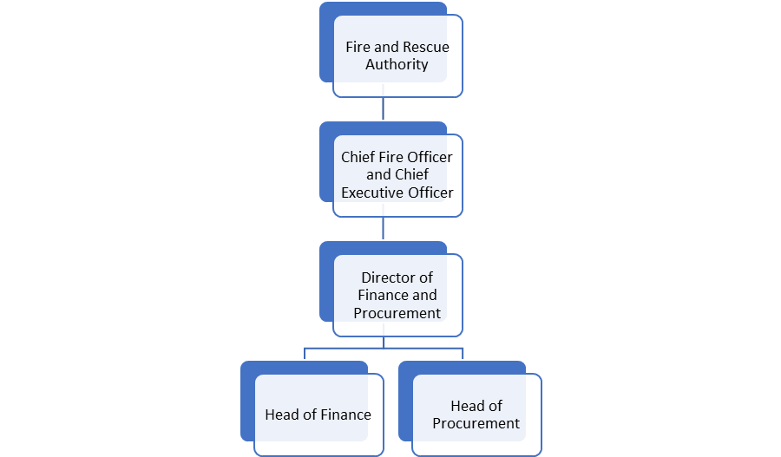

Main duties and responsibilities of the role.
1. Statutory Responsibilities.
1.1. The Director of Finance and Procurement has statutory duties in relation to the financial administration and stewardship of the Authority. This statutory responsibility cannot be overridden. The statutory duties arise from:
- Section 73 and 105(1) of the Local Government Act 1985.
- The Local Government Finance Act 1988.
- The Local Government and Housing Act 1989.
- The Accounts and Audit Regulations 1996 and 2003.
- Procurement Act 2023.

1.2 The Director of Finance and Procurement is responsible for:
- the proper administration of the Authority’s financial affairs.
- setting and monitoring compliance with financial management standards.
- advising on the corporate financial position and on the key financial controls necessary to secure sound financial management.
- providing financial information.
- preparing the revenue budget and capital programme.
- treasury management.
- provision of insurance.
- payment of salaries and wages.

2. Financial Management.
2.1 Lead, direct and manage the preparation of the revenue budget, capital programme and short, medium and long-term financial strategy for presentation to the Authority.
2.2 Lead, direct and manage the preparation and certification of statutory accounts in accordance with accounts and audit regulations and statement of recommended accounting practice.
2.3 Lead, direct and manage the preparation of regular and timely budget monitoring reports on both the Revenue Budget and the Capital Programme, to identify variances.

2.4 Lead, direct and manage the provision of appropriate financial information to directorates to enable the budget to be managed effectively.

2.5 Determine with Executive Leadership Team (ELT) colleagues the financial implications of all policy developments, changes in service plans and capital projects.

2.6 Review with the ELT the effectiveness and efficiency of current service plans, to provide independent challenge and to develop options for different forms of delivery.

2.7 Lead, direct and manage the maintenance of the financial accounting processes to ensure that statutory accounts and associated claims and returns in respect of grants are prepared.

2.8 Advise on corporate risk profiling and management including safeguarding assets risk avoidance and insurance

2.9 Advise managers on arrangements for effective internal control and financial procedures. These arrangements need to ensure compliance with all applicable statutes and regulations.

2.10 Lead, direct and manage the payment of salaries, members’ allowances and creditors and the receipt of business related income.

2.11 Assist service managers to identify sources of external income.

2.12 Provide an effective internal audit function and assist managers in providing effective arrangements for financial scrutiny.

3. Corporate Management.
3.1 Member of the Authority Corporate ELT.

3.2 Contribute to the effective management and leadership of the Authority.
3.3 Ensure the Authority’s financial resources are well managed.
3.4 Advise the Chief Fire Officer and Chief Executive and ELT Directors on strategic financial issues.

4. Supporting and Advising the Democratic Process.
4.1 Provide clear, impartial, professional advice to the Authority, its committees and individual members.
4.2 Brief, along with the Chief Executive, political groups on the impact of the revenue budget and capital programme.

5. Treasury Management.
5.1 Formulate borrowing and investment strategies.
5.2 Ensure compliance with CIPFA’s Prudential and Treasury Management Code.
5.3 Design, implement and monitor arrangements for the identification management and control of treasury management risk.
5.4 Recommend treasury management policy/practices for approval and review regularly.

6. Leadership and Management of the Finance and Procurement Function.
6.1 Lead and manage the finance and procurement function.
6.2 Manage the performance and personal development of finance and procurement colleagues.
6.3 Make arrangements for the training of managers and staff on financial issues, as required.
7. Corporate Responsibilities.
7.1 Represent the Authority where appropriate on national working groups when required.
7.2 Prepare responses to government consultation documents.
7.3 Represent the Authority on the NFCC fire authorities’ finance group.
7.4 Liaise with HMRC on issues of taxation affecting both the Authority and its employees.

Organisational wide responsibilities.
- Adherence to the NFCC Code of Ethics and West Yorkshire Fire Service Values.

- To implement and promote the Authority’s:
- Health and Safety policies.
- Equality and Diversity policies.
- Information Security Management System policies.
- Safeguarding policies.
- Business continuity policy and contingency arrangements.
- Policies related to General Data Protection Regulation and Data Protection Act 2018.
- Commitment to maintaining our Customer Service expectations.
- A satisfactory Standard Disclosure and Barring check is required for the role.
- This post has been designated a hybrid working post which means the postholder’s working time will be split between the workplace and home. The actual pattern and number of days at each will be agreed locally with the line manager and will be determined based on the service needs.

Skills and experience requirements for this role.
In the supporting statement section of the application form give clear, concise examples of how you meet all of the Essential person specification criteria (i.e. items you must be able to do from day one to be able to do the job), identified as ‘Application’ in order to be shortlisted for this vacancy. If a large number of applications are received, only those who also meet the Desirable criteria, identified as ‘Application’, will be shortlisted, i.e. criteria you need to do the job, but which could be learnt during training.
Please list or number the competency criteria below against which you are providing evidence/examples in order to structure your supporting statement in a well organised way.
There may be some criteria that are identified through ‘Selection Process’ only. You will only be assessed on these criteria during the selection process and not from your application form, this may involve tests, presentations, interview etc.
 | Experience. | Essential/Desirable. | Where identified.
 | Experience of leading high performing finance and procurement teams that have achieved service excellence. | Essential. | Application & Selection Process.
 | Experience of formulating the council tax requirement, the medium-term financial strategy and producing a set of statutory accounts. | Essential | Application & Selection Process.
 | Demonstratable experience of translating complex financial information into written reports and policy. | Essential. | Application & Selection Process.
 | Experience of preparing and presenting detailed financial reports and recommendations to the Executive Board. | Essential. | Application & Selection Process.
 | Experience briefing elected members both at committee and individual level. | Desirable. | Application & Selection Process.
 | Experience of delivering people focused, transformational change programmes/new operating models inclusive of agile development of new financial systems and platforms. | Essential. | Application & Selection Process.
 | A proven ability to coach and develop finance and procurement team members and to encourage, enable and support them to reach their potential. | Essential. | Application & Selection Process.

 | Education and Training. | Essential/Desirable. | Where identified.
 | CCAB accountant. | Essential. | Application.
 | Undertake CPD or be able to demonstrate action taken that maintains up to date relevance of accounting qualification. | Essential. | Application.
 | Leadership and management qualification. | Desirable. | Application.

 | Special knowledge and skills. | Essential/Desirable. | Where identified.
 | Extensive knowledge of financial procedures and systems relevant to a public sector organisation developed over a period of at least five years post qualification. | Essential. | Application & Selection Process.
 | A good understanding of accounting code of practice, accounting conventions and accounting standards. | Essential. | Application & Selection Process.
 | Sound knowledge of standing orders and financial regulations of a major public body. | Essential. | Application & Selection Process.
 | An understanding of the democratic processes of policy within local government. | Essential. | Application & Selection Process.
 | Highly articulate (in writing and orally) with strong engagement and influencing skills. | Essential. | Application & Selection Process.
 | An empowering, compassionate, collaborative and motivating leadership style with the ability to engage and motivate people to deliver results in line with strategic objectives. | Essential. | Application & Selection Process.
 | Politically astute and able to navigate organisational politics and culture effectively. | Essential. | Application & Selection Process.
 | Strong analytic and critical reasoning skills, is capable of effective problem solving and uses data to drive decision making. | Essential. | Application & Selection Process.
 | Demonstrates commitment to taking a leading role in driving forward WYFRS’ commitment to Equality & Diversity, NFCC Core Code of Ethics and WYFRS values. | Essential. | Application & Selection Process.
 | To hold and maintain a current full UK valid car driving licence and/or ability to travel between Fire Service properities within West Yorkshire. | Desirable | Application & Selection Process.

Job Description last updated: May 2026.

