Candidate Pack

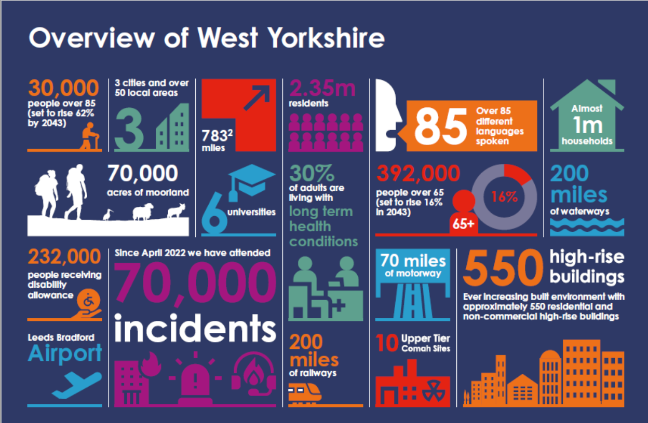

We are the statutory emergency fire and rescue service for the metropolitan county of West Yorkshire, England. We are administered by a joint authority of 22 councillors who are appointed annually from the five metropolitan boroughs of West Yorkshire, known as the Fire & Rescue Authority.
We serve a population of more than two million people, spread over 783 square miles, providing emergency cover 24 hours a day, every day of the year.
Our headquarters and training centre in Birkenshaw, is a new state-of-the-art facility.
There are over 1,400 people who work for WYFRS ensuring that we deliver the highest standards of prevention, protection, response and resilience to the communities of West Yorkshire. We have 953 whole-time firefighters, 140 on-call firefighters, 47 Fire Control operators, and 340 support staff, who all contribute daily to 'Making West Yorkshire Safer'.
We operate out of 40 fire stations, located across the five districts: Bradford, Calderdale, Kirklees, Leeds, and Wakefield.
We have 46 Emergency Fire Appliances, 4 Aerial Appliances, a Technical Rescue Unit and a number of resilience appliances available to ensure we are operationally ready whenever needed. We also host a suite of specialist resources that can be deployed anywhere in the UK, including high volume pumps, flood response, wildfire response, urban search and rescue, and response to chemical, biological, radiological, or nuclear hazards.

To find out more about WYFRS and our strategic priorities, please visit Your Fire and Rescue Service 2025-28 | West Yorkshire Fire and Rescue Service

Welcome Message from John Roberts, Chief Fire Officer.

Thank you for your interest in the role of Director of Finance and Procurement at West Yorkshire Fire & Rescue Service.
This is a significant opportunity to join our Executive Leadership Team (ELT) at a time when strong, forward-thinking leadership in public finance has never been more important. Our organisation is committed to protecting the communities we serve through prevention, protection and emergency response, and the effective stewardship of our resources is central to achieving that mission.
As our Director of Finance and Procurement, you will play a vital strategic role in shaping the future sustainability and resilience of the Authority. Beyond ensuring excellence in financial management, governance and procurement, we are seeking a leader who can bring insight, innovation and collaborative thinking to support organisational transformation and continuous improvement.
A key aspect of the role will be supporting me and the ELT in responding to the opportunities and challenges presented through devolution. This will include providing strategic financial leadership, supporting long-term planning and helping to shape the Authority’s approach within an evolving regional and public sector landscape.
We are proud to be a values-led organisation with a strong commitment to public service, integrity, inclusion and accountability. We are looking for someone who shares those values and who can build strong relationships with Members, colleagues, partners and stakeholders across West Yorkshire and beyond.
This role requires not only technical expertise, strategic capability, and change leadership but also the ability to inspire and develop others, provide clear and trusted advice, and help navigate the challenges and opportunities facing the public sector.
I hope the information in this candidate pack gives you a sense of both the scale of the opportunity and the ambition of our organisation. If you are passionate about public service and believe you can make a positive contribution to our future, I would be delighted to receive your application.
Thank you again for your interest in joining West Yorkshire Fire & Rescue Authority, and I wish you every success in the recruitment process.

John Roberts
Chief Fire Officer and Chief Executive Officer

Salary and Benefits.

Salary.
£124,490 - £131,043 per annum.

Hours.
37 hours per week, flexible working and subject to the exigencies of the service.

Where will I be based?
The post holder will be based at West Yorkshire Fire and Rescue Service Headquarters. Occasional travel to fire stations and national events will be required.

Benefits.
At WYFRS our people are at the heart of everything we do. It is crucial that our employees have the right skills to develop their careers and meet the challenges ahead, you will benefit from regular performance and development conversations to ensure your development is ongoing.

As a WYFRS employee, you will have access to a favourable total reward package designed to support your wellbeing and make a positive difference to your day-to-day life, including:

- 27 days annual leave, rising with long service. This is in addition to 8 public holidays.
- A car lease scheme or alternative car allowance.
- Onsite facilities including free car parking and gym.
- Family friendly and flexible working.
- Entry to the Local Government Pension Scheme.
- Wellbeing support including access to counselling services, physiotherapy and a wide range of welfare support.
- Sports clubs and societies.
- Enhanced maternity and family support pay and leave options.

Application Process

Application | To apply for the role you will need to complete the online application process no later than 23:55 on Sunday 21 June. The application will include:  - A CV setting out your career history, with key responsibilities and achievements. Please ensure you have provided reasons for any gaps.  - A statement of suitability (no longer than 2000 words) explaining who you consider your personal skills, knowledge and experience provide evidence of your suitability for the role. You should cover all the essential knowledge, skills and experience requirements set out in the candidate pack.  Failure to complete both sections will mean the panel only have limited information on which to assess your application.
Shortlist | We hope to notify candidates of the results of shortlisting no later than week ending 22 June 2026.  A panel, including the hiring manager, will assess your application to select those demonstrating the essential knowledge, skills and experience for the role.
Assessments | You will be required participate in a Stakeholder Engagement Panel and undertake a technical interview and work sample exercise.  Full details of the assessments will be provided to shortlisted candidates. Assessments are designed to support the panel’s decision making and highlight areas for further exploration.
Interview | The final interview will be chaired by the Chair of the Fire and Rescue Authority. It will include a presentation, and you will have the opportunity to have an in-depth discussion of your previous experience and professional competence.  Full details, including the panel composition will be provided in advance.

Indicative Timeline.

Advert close date (Application and statement of suitability) | Sunday 21 June
Shortlisting | W/C 22 June
Assessments/Stakeholder Panels | W/C 29 June
Interviews | W/C 6 July

