Gender Pay Gap Report
  - 2025
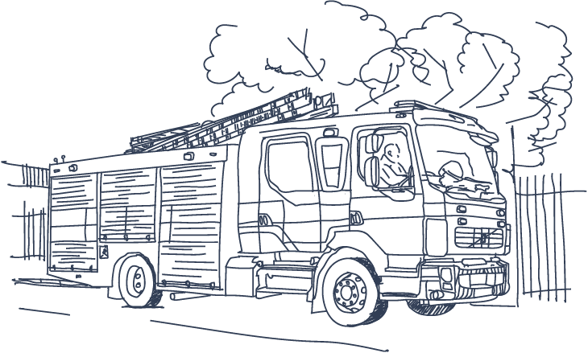

Ownership: Ian Stone, Head of Organisational Development, Skills & Talent
Date Issued: 06/03/2025
File ID: Gender Pay Gap Report 2025/26
Version: Version1
Status: Final

Contents

Statement from the Chief Fire Officer, John Roberts & Chair of West Yorkshire Fire & Rescue Authority, Councillor Darren O’Donovan 3
Introduction 4
Regulatory Requirements 4
West Yorkshire Fire and Rescue Service Gender Pay Data 5
Workforce Information – Total Employees 5
A) Mean (Average) Pay Gap 5
A) Median Pay Gap 7
B) Salary Quartile Bands 8
Whole Organisation 8
Comparison (Male/Female Distribution – All Quartiles) 9
Enabling Functions – Green Book 9
Operational Colleagues – Wholetime, On-Call & Fire Control 9
D) to G) Bonus Payments 10
Progress and Steps Taken 11
Going Forward – What next? 13

Statement from the Chief Fire Officer, John Roberts & Chair of West Yorkshire Fire & Rescue Authority, Councillor Darren O’Donovan
We monitor and report on gender pay gap annually. Our pay and grading structure is based on the job, not who occupies it. We deliver equitable treatment for everyone who works with us, regardless of personal circumstances and protected characteristic(s). We are proud to report a reduction yet again in our gender pay gap. Our commitment to an inclusive workforce is unwavering. Steps we take to move forward, including outreach and positive action measures, and work to raise West Yorkshire Fire Service’s (WYFRS) profile amongst underrepresented groups as a great and inclusive place to work are making a difference.
Our salary scales are available for anyone to view as we believe in pay transparency. Pay rates clearly show everyone doing the same job is paid a salary within the same grade or range. Incremental pay increases are based on experience and performance alone.
We continue to take steps to make sure females who share fire service values and are thinking of a career as a firefighter are encouraged to join us; this is having a positive impact. We see more females within WYFRS, particularly in firefighting roles, though we are not complacent. There remain significantly more males than females in operational roles. We deliver events and initiatives to reach out and enable females (and people from underrepresented groups) to join and progress with us. We continue to improve how we reach, connect with and recruit people from across the communities of West Yorkshire. We deliver positive action and other practical steps to shift our gender imbalance in operational firefighting roles. Being a firefighter is a tough but incredibly rewarding career, and your sex or other protected characteristics is not a barrier to making West Yorkshire Safer from fires and other emergencies.
We continue identifying, understanding and where appropriate removing barriers. We stand up for what is right and work hard to maximise opportunities for underrepresented people. Women and people from underrepresented groups can and do make fantastic WYFRS Firefighters and we work regionally and nationally to influence and share best practice highlighting positive differences and showcasing our diverse people and roles.
WYFRS gender pay gap stands at 7.2%, tracking 46% below the ONS data of 13.4% for 2025 (Provisional) and 20% below the 9% pay gap data for the five Local Authorities within West Yorkshire. We pay people based on a transparent salary range for the job. People are appointed on their values, behaviours, experience, and expertise alone; pay structure doesn’t favour any group.
We continue to move forward over the longer term and continue making progress, though the way ahead is long. Our projects, outreach and positive action measures continue to help move us forward to achieve the enormous benefits a diverse workforce and an inclusive organisation bring to our people and the communities of West Yorkshire.
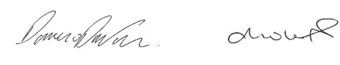
Cllr Darren O’Donovan John Roberts
Chair of the Fire Authority Chief Fire Officer

Introduction
West Yorkshire Fire and Rescue Authority (WYFRA) carries out Gender Pay Reporting under the Equality Act 2010 (Gender Pay Gap Information Regulations 2017).
Gender pay reporting is used to compare pay rates and bonuses paid by gender. At WYFRA all jobs are evaluated against a consistent pay and grading scheme and allocated to a specific grade range based on the evaluation of the job, not the person. People who join or change jobs are appointed to an agreed pay point for each job. Pay rates are transparent and everyone is appointed based on knowledge, skills, and experience within salary range for the role.
The Gender Pay Gap enables WYFRA to understand pay data from a gender equality perspective. The report illustrates the balance of male and female employees at different pay levels and enables the organisation to put steps in place to address any inequalities identified.

Regulatory Requirements
The regulations give a wide definition of who counts as an employee, (e.g. the self-employed & agency workers); for WYFRA this includes all employees of West Yorkshire Fire and Rescue Service (WYFRS) regardless of role and terms and conditions of employment.
To report the Gender Pay Gap there are six calculations organisations must carry out:
- Mean pay gap – average hourly pay for males compared with females.
- Median pay gap – mid-way point from lowest to highest hourly rates for males compared with females.
- Male and female employees in each salary quartile band.
There are a further three calculations required under the regulations, which do not apply to because the organisation does not pay any bonus:
- The mean (average) bonus pay gap.
- The median bonus pay gap.
- The proportion of males and females receiving a bonus payment.
WYFRA voluntarily shares additional pay data in the spirit of transparency. Figures reported are calculated using methodologies from the Equality Act 2010 (Gender Pay Gap Information) Regulations 2017 using guidance issued by the Women & Equalities Office (WEO) and ACAS.

West Yorkshire Fire and Rescue Service Gender Pay Data

Workforce Information – Total Employees
The report data is as of 31 March 2025. For reporting purposes, our workforce is designated into five separate employee groups.
- Enabling Functions, our support and service delivery teams who provide professional services, deliver prevention or protection responsibilities, and enable our operational (firefighting) workforce to deliver.
- Operational Whole Time: our professional firefighting colleagues and people in front-line firefighting operations and operational ranks.
- Fire Control: colleagues who take and prioritise emergency fire calls and carry out initial incident management until our fire crews arrive.
- On Call: Firefighters who provide services within communities where a whole-time station is not provided.
- Community Response: a response team in the event of withdrawal of services by firefighters, e.g. during strikes.
WYFRS Staff 2025 Data*
Employee Group | Female | Male
Enabling Functions | 182 | 159
Operational Whole Time | 98 | 844
Fire Control | 32 | 15
Community Response | 0 | 26
On Call | 12 | 129 | Totals
Totals | 324 | 1173 | 1497
Figure 1: Table showing male and female employees and their employee group.
* Includes all roles, not just people included in pay gap reporting.

A) Mean (Average) Pay Gap
In 2025 average hourly rates for females increased by £0.58 to £18.28. In 2024 Average pay was £17.70, in 2023 this was £16.59. Male average hourly rates for 2025 were £19.69, an increase of £0.54, (Hourly rates for males in 2024 were £19.15, and £18.09 in 2023).
The gender pay gap has decreased to 7.2% this year, dropping a further 0.4%. in monetary terms reducing from £1.45 per hour in 2024 to £1.41 in 2025. This gap equates to females having to work an additional 3 hours and 14 minutes each week (based on 42 hours) to achieve the same average (mean) earnings as males, a significant reduction of 30 minutes on the previous year.
2025 | Female | Male | £ Gap | % Gap | Change | Trend  nNegative  nSlight Change  nPositive
All - Mean (Average) Hourly Pay | £18.28 | £19.69 | £ 1.41 | 7.2% | 0.4% | ê
Operational Whole Time | £18.28 | £20.18 | £ 1.91 | 9.5% | 3.5% | ê
On Call | £15.87 | £17.24 | £ 1.37 | 8.0% | -1.3% | é
Control | £17.58 | £16.88 | -£ 0.71 | -4.2% | -1.5% | ê
Enabling Functions | £18.55 | £18.87 | £ 0.30 | 1.6% | 6.4% | ê
Community Response |  | £13.40
Figure 2: Table showing the mean (average) hourly pay.
The pay gap for Firefighting colleagues (Grey Book) has reduced significantly and now stands at 9.45%, tracking lower than the 12.9% in 2024 and 10.5% in 2023. On Call has seen an increase in the pay gap, now standing at 7.95%, an increase on 2024’s 6.7%, it was 9.4% in 2023.
Enabling Functions (Green Book) have seen the biggest change, with the pay gap reducing significantly by 6.6% to 1.61%, which is the narrowest gap reported. In 2024, the pay gap was 8.2% and 9.6% in 2023.
Pay gap data changes recorded are a result of staff turnover and the sex of the postholder, particularly in more senior roles. The Senior Operational workforce continues to show more males than females in upper quartile roles, whilst in Enabling functions this has shifted to show more balance. Overall, the Gender Pay Gap data is shifting towards a reduced pay gap, in 2025 this is 7.16%, below the 7.6% reported in 2024 and the third lowest on record.
WYFRS pay gap tracks significantly below ONS (Office for National Statistics) national pay gap data for 2025 which stands at 13.4%; the WYFRS pay gap is 6.2% below. The chart below illustrates organisational pay gap performance over reporting years. The WYFRS gender pay is consistently lower than the official ONS UK figure and the West Yorkshire County Data.
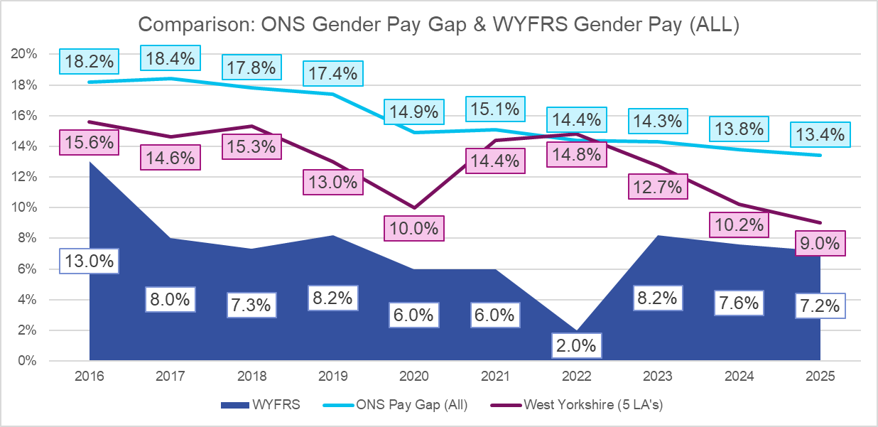
Figure 3: WYFRS Trend Comparison with ONS & WYCA Data
Comparing WYFRS with ONS pay gap data, Yorkshire, and the Humber and the five West Yorkshire Local Authority Areas (WY Region) provides a positive picture for the organisation as both the regional and national figures are higher than WYFRS:
- UK ONS Data – 13.4%, 6.2% above WYFRS
- Yorkshire & Humber - 12%, 4.8% above WYFRS.
- West Yorks (5 LA’s) - 9%, 1.8% above WYFRS.

Median Pay Gap
2025 | Female | Male | Gap | % | Gender Difference from 2024
Median Hourly Pay | £ 17.20 | £ 18.55 | £1.35 | 7.3% | 0.9% é
Operational (Grey Book) | £ 17.73 | £ 19.32 | £1.59 | 8.2%
On Call | £ 17.20 | £ 17.20 | £ - | 0.00%
Fire Control | £ 16.83 | £ 17.37 | £0.54 | 3.1%
Enabling (Green Book) | £ 16.37 | £ 18.72 | £2.35 | 12.6%
Figure 4: Median pay by employee group and male/female.
The median pay gap has increased by 0.9%, standing at 7.3% overall, up 0.9% from 2024. Our pay structure is transparent. Jobs are graded around a nationally determined and fixed grading structure for Firefighters (Currently under review) and enabling colleagues (Green Book) pay rates are aligned with fire / public sector pay, objectively graded on job requirements, not post holder; there is no difference in how male and female pay is set for equivalent roles.
The median pay gap has increased in cash, standing at £1.35, up from last year’s £1.12 in 2024. The median salary pay difference shows males still earn more than females. The biggest change across the organisation occurs in Enabling Functions / Green Book. This has reduced by 2.24% to 12.56% from 2024 when it stood at 14.8%.

Salary Quartile Bands
A quartile is defined as four equal ‘slices’ of pay data which by the proportion of females and males in each; as a result, there are people on the same hourly rate showing in two quartiles.
Data is split by the whole organisation, Enabling and Firefighting colleagues as shown by the tables below.

Whole Organisation
Salary Quartile Bands – Overview 2025
Gender | High | Gender Difference from 2024 | Mid (Upper) | Gender Difference from 2024 | Mid (Lower) | Gender Difference from 2024 | Low | Gender Difference from 2023
Female | 16% | 0% | 18% | 0% | 13% | 5%é | 40% | 1% ê
Male | 84% | 0% | 82% | 0% | 87% | 5%é | 60% | 1% ê
 | 0% |  |  |  | 4% é
Figure 5: Whole organisation salary distribution by quartile.
Salary Quartile Bands - Whole Organisation 2025
Quartile | Hourly Rate Range | Females | % Females | Males | % Males | Gender Difference from 2024
Upper | £21.08 - £87.14 | 58 | 15% | 317 | 85% | 4% é
Mid Upper | £18.21 - £21.04 | 66 | 18% | 308 | 82% | 6% ê
Mid Lower | £17.20 - £18.15 | 49 | 13% | 325 | 87% | 1%çè
Low | £12.26 - £17.20 | 151 | 40% | 223 | 60% | 4% ê
Total |  | 324 |  | 1173
Figure 6: Whole Organisation Quartile Pay
The small changes shown on the previous page are positive and though we aren’t seeing much change in High or Mid Upper quartiles there is an increase in females (10% more females, 3% more males). The increase in female representation within the top salary quartile, (up one to 58) and mid lower quartile (Up by 20) is good to see. This demonstrates the impact of attraction and positive action work showing gradual changes in role distribution.

Comparison (Male/Female Distribution – All Quartiles)
Looking at males and females separately highlights a concentration of 47% of females in the bottom quartile, down by 2%, compared with 19% of males. Females make up 18% of the top quartile, though primarily because there are significantly more top quartile roles in the operational workforce, most of which are occupied by males.
Figure 7: Chart showing distribution as a percentage between males and females in each quartile.

Enabling Functions – Green Book
Enabling Teams (Green Book) 2025
Quartile | Hourly Rate Range | Female | % Female | Male | % Male | Gender Difference from 2024 | Grand Total
Upper | £20.56 - £68.79 | 44 | 52% | 41 | 48% | 4% é | 85
Mid Upper | £17.29 - £20.48 | 31 | 36% | 55 | 64% | 13% ê | 86
Mid Lower | £14.60 - £17.29 | 47 | 55% | 38 | 45% | 3% é | 85
Low | £12.77 - £14.60 | 52 | 60% | 34 | 40% | 11% ê | 86
Total |  | 174 |  | 168 |  |  | 342
Figure 8: Enabling Teams pay data by quartile.
This reporting year has seen a slight increase in headcount by 42, 8 females and 34 males. The proportion of females in the top quartile has risen by 4%, offset by a reduction of males by the same margin. There has been a significant shift in the low quartile where the significant overrepresentation of females in 2024 (71%) has moved by 11% closer to parity. The mid upper quartile has seen a drop in female representation by 13%.

Operational Colleagues – Wholetime, On-Call & Fire Control
Operational Teams (Grey Book) 2025
Quartile | Hourly Rate Range | Female | % Female | Male | % Male | Gender Difference from 2024 | Grand Total
Upper | £21.30 - £87.14 | 22 | 8% | 267 | 92% | 1%é | 289
Mid Upper | £18.25 - £21.27 | 27 | 9% | 262 | 91% | 1% ê | 289
Mid Lower | £17.20 - £18.24 | 33 | 11% | 256 | 89% | 3%é | 289
Low | £12.26 - £14.60 | 60 | 21% | 229 | 79% | 1%é | 289
Total |  | 142 |  | 1014 |  |  | 1156
Figure 9: Quartile data for firefighters wholetime, On Call and fire control.
Further slight changes across most quartiles are seen here, the mid lower has seen the most change up 3% on last year. As more females are recruited, this begins to show across the numbers of operational females in role, now standing at 142.
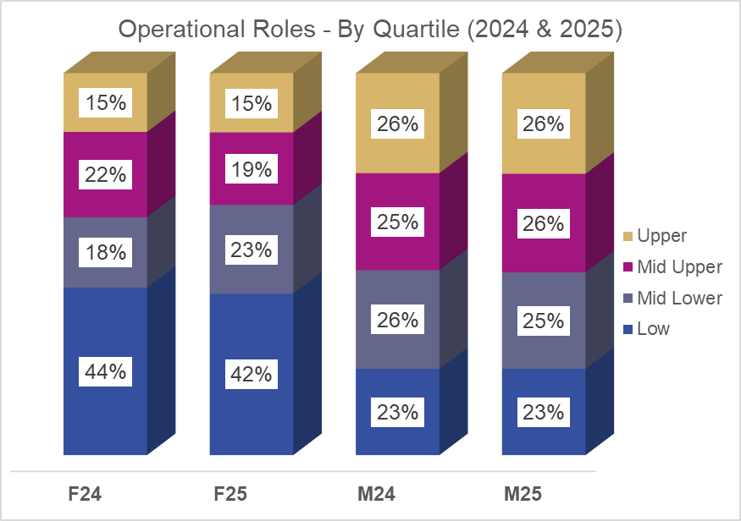
Figure 10: Chart to show quartile split by male and female operational roles.
The chart above highlights the proportion of male and female staff in each quartile. The data clearly shows the split across quartiles for male firefighting colleagues is fairly even, but for females, there is a greater concentration in the low quartile which has reduced by 2% to 42%; an increase of 5% in the lower-mid quartile to 23%, a slight decrease of 3% in the mid upper quartile and the top quartile remains static. The rise in women in the mid lower quartile is as a result of pay progression and more females stepping up into first line management roles.

to G) Bonus Payments
The Fire Service does not offer a bonus scheme. Therefore:
- The mean bonus pay gap - N/A
- The median bonus pay gap - N/A
- The proportion of males receiving a bonus payment - N/A
- The proportion of females receiving a bonus payment - N/A

Progress and Steps Taken
The mean (average) gender pay gap has changed significantly to 4.5%. This is tracking favourably when compared with the Yorkshire and Humberside pay gap of 11.6%, the West Yorkshire pay gap data at 12.2%, and the national pay gap of 13.1%.
The West Yorkshire Fire and Rescue Service pay gap continues to track much lower than the ONS and has done so in all reporting years since gender pay gap reporting began.
The key reasons for the pay gap remain consistent:
- More males than females in operational roles. There are a greater number of females in operational roles than ever before and there are continued positive signs in this area. Positive action, increased engagement, and improvements in targeted recruitment campaigns have encouraged more females to apply and join the service. However, though more female are joining than in the past the headcount shows a relatively small proportion of females in operational roles. This challenge remains common across the Fire and Rescue labour market; progress is slow but positive:
- Significant and sustained efforts to attract females for upcoming recruitment campaigns, with deployment of targeted advertising, development workshops, and other engagement opportunities alongside positive action outreach.
- Removing the bleep test as the first step in recruitment following data evaluation which showed a disproportionate effect on females; replacing with an online task based assessment as stage one and Chester Treadmill as the first physical assessment, which tests to the same fitness standard in a more inclusive way.
- Updating the promotions / development process, which shifts ranks from Crew Manager to Station Manager from a pure ‘recruit/develop’ model to a hybrid ‘develop/recruit’ approach. This focus on achieving Phase one of development first has seen greater numbers of females coming forward for development at Crew and Watch Manager roles and Station Manager level too.
- Establishing MAGNet – a network to hear from our female workforce (and allies) about the impacts on menopause in the workplace, including considerations around PPE, working conditions and operational impacts through a menopause action plan.
- We are active regionally and nationally through work with the National Fire Chiefs Council (NFCC), including leading national groups.
- Proactive involvement from ‘FireWAW’ (Women at Work Staff Network) to understand barriers females face and deliver projects to overcome these where possible; recent examples include working with us on improving our maternity and adoption pay offer and delivering skills events for females in WYFRS.
- White Ribbon, a global movement to end violence against women and girls by promoting respect, equality, and compassion and through our male Ambassadors and female Champions. This work further showcases WYFRS as a safe and inclusive place for females to work.
- WFS (Women in the Fire Service) involvement at national, regional, and local level, including a phenomenally successful WYFRS event.
We continue to work hard to position West Yorkshire Fire and Rescue Authority as an employer of choice and remain proud of our record.
Our transparent pay structure means we can be sure any gender pay gap does not stem from paying male and female differently for equivalent work. The gender pay gap is a result of the specific roles in which male and female currently work within the organisation and the salaries each role attracts.
WYFRS has already taken steps to encourage gender parity, including:
- Consolidating our evidence base: Equality Data is routinely captured as people join us, but there are gaps in the data held on employees with longer service; work is underway to encourage people to update their data:
- Work continues to identify barriers in firefighter recruitment and implement improvements that maintain our incredibly high standards but also identify and remove bias, for example incorporating online first stage testing and implementing the Chester Treadmill to assess fitness.
- Empowering our Female’s Staff Network to highlight challenges, gather and review data, share stories, and influence decision-making to further narrow the gap, including work alongside other Blue Light Services.
- Raising the profile of sex and gender issues: the organisation is keen to ensure issues are high on the agenda and continues to offer a rolling programme of activities and training events to promote awareness. This includes:
- A seat on our Diversity, Equity, and Inclusion Board (a strategic body) for the Chairs of FireWAW (Women’s Network) and MAGnet (Menopause Network) to ensure issues raised are actioned at a strategic level, including a board-level champion with each and Elected Member involvement.
- Celebrating International Women’s Day and International Men’s Day.
- Giving a genuine voice to employee networks, including our Women’s Network, with a membership of females and input from male allies.
- A menopause network has been established and trained to ensure the organisation understands impacts of menopause on females but particularly operational females.
- Championing the great work of Women in the Fire Service (WFS), with continued and increasing representation regionally and nationally. We also open access to females within WYFRS to networking, skills development events, and annual ‘WFS Weekend.’
- Implementing significant improvements to our Equality Impact Assessments (EIA’s) including consultation and input from members of the colleague networks to ensure issues that impact females are highlighting and addressed where possible.
- Removing Inequality Through Impact Assessments: A simplified ‘Power App’ for EIAs is delivering significant improvements in identification, and action to address barriers. This improves fairness and equity across projects, policies, and facilities. Recent examples include a Station Design Guide, New HQ facilities and work to deliver a new Welfare Unit (Showers, changing facilities).

Going Forward – What next?
Work focuses on initiatives to expand career development and learning opportunities for females. Recent changes to how we deliver development for operational colleagues seeking promotion removes potential for bias as does fair, open and transparent recruitment for promotion.
There are limited opportunities to address the gender pay gap through recruitment. The organisation is fortunate to retain the talent it has, and voluntary attrition, particularly for operational females remains low, though there are females in senior operational roles who are eligible to retire or may take roles outside of the service over the coming year which may presents a challenge to sustain the current low pay gap. The sustained public / private sector pay gap continues to impact turnover. We continue to drive changes to make a positive impact:
- Leadership and Manager Development: Significant and ongoing training is delivered to current and aspiring managers using internal and external experts to equip managers with a deeper understanding of management and leadership. A greater focus on developing people before promotion is delivering results and will continue. We are working on a bespoke 360 degree assessment tool which integrates national leadership Fire Standards, Fire Leadership Framework and WYFRS Behaviours Framework. A Talent stream, learning programme and diagnostics will be implemented with positive action embedded.
- The Women in the Fire Service (WFS) Development Programme: Now part of our annual inclusion programme following fantastic feedback; attendance at national development events, in service sessions and ‘Have a Go’ days as we aim to increase female representation.
- Legislative Updates: The implementation of the Worker Protection (Amendment of Equality Act 2010) Act 2023 adds a new duty to prevent sexual harassment, though not specifically connected to pay gaps it is highlighted here as another step we take to ensure female colleagues are protected and included.
- Parent and Carer Support: WYFRA has a range of family-friendly policies we are proud of, including generous maternity leave, adoption leave, and other leave for emergencies such as caring responsibilities. A greater flexibility through the deployment of hybrid working contracts for enabling colleagues supports people with caring responsibilities, who are more likely to be female. The updated flexi-time policy offers greater flexibility in working hours to support a better work-life balance.
- Menopause & Menstrual Health: We are proud of our range of support measures for females experiencing menopause, taking specific steps to research operational impacts and support females during their menopause journey. We now have an active and well-informed menopause network who are working on even better information and an awareness toolkit for managers and colleagues alike to ensure everyone is aware of menopause and the impact some females experience, particularly our operational colleagues. In addition, we are developing additional menstrual health guidance to support our female workforce. We are focused on support and understanding. Our Occupational Health and Wellbeing team provides advice and specific adjustments as required. WYFRS remains at the forefront of this work.
- Positive Action Outreach & Community Engagement: We achieve significant impacts and are proud of steps taken to get closer to our communities and how we showcase WYFRS as a great employer, though there is much to do. Working closely with WYFRS females delivers greater positive impact, challenges stereotypes, and delivers key messages effectively. We deliver tailored interventions before Firefighter recruitment to support and enable females to get to the ‘start line’; through support for fitness, interview skills, and targeted role advertising.
- Personal Protective Equipment (PPE): Our FireWAW Network (Women at Work) is connecting with academic researchers to review PPE to make sure it is suitable for females, fits properly and does the job required. In addition, work is underway to include a hijab which is suitable for wear on the incident ground to our uniform; this engagement includes working with community members, listening and acting on their advice.
We take the work seriously and work tirelessly to deliver actions to further reduce our pay gap. This report shows our data ‘warts and all’ and demonstrates the many positive steps taken in this, and every year helping us move further in the right direction.
I, John Roberts, Chief Fire Officer and Chief Executive Officer, confirm the information in this statement is accurate.
Date: March 2026 Signature:

