West Yorkshire Fire & Rescue Service
  - Job Description
Post Title: PAIT (Prevention, Assurance & Improvement Team) Performance Coordinator.
Grade: 6.
Responsible To: PAIT Manager.
Purpose Of Post: To coordinate and enhance risk reduction and performance monitoring processes within the Prevention Strategy by establishing quality assurance standards, facilitating organisational learning, supporting managers to ensure effective service delivery and continuous improvement.

Main duties and responsibilities of the role

- Establishing effective tools and procedures for accurate performance monitoring across various aspects of service delivery; undertaking performance analysis for all Prevention and Operational staff, providing feedback, issuing guidance and detailed reports to support staff development.
- To develop and implement Quality Assurance standards, supporting processes and practices aimed at increasing prevention performance and ensuring adherence to national guidelines, using lessons learned to recommend improvements and ensure ongoing effectiveness.
- To facilitate and improve organisational learning by conducting in-depth incident analysis, maintaining up to date risk profiles, interacting with service users, leading on the After Fire learning process, and contributing actively to related panel meetings; collaborating across departments and with other FRS to address emerging issues, seasonal trends, gaps in service, and communication priorities.
- Responsible for the day to day tasking and supervision of the PAIT Officers. Acting as the first point of contact for any health and safety matters related to lone, and out of hours working.

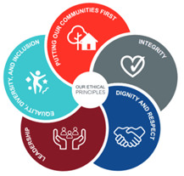
Organisational wide responsibilities
- Adherence to the NFCC Core Code of Ethics and West Yorkshire Fire Service Values.
- To implement and promote the Authority’s:
- Health and Safety policies.
- Equality and Diversity policies.
- Information Security Management System policies.
- Safeguarding policies.
- Business continuity policy and contingency arrangements.
- Policies related to General Data Protection Regulation and Data Protection Act 2018.
- Commitment to maintaining our Customer Service expectations.
- A satisfactory Enhanced Disclosure and Barring check is required for the role.
- This post has been designated a hybrid working post which means the postholder’s working time will be split between the workplace and home. The actual pattern and number of days at each will be agreed locally with the line manager and will be determined based on the service needs.

Organisational chart
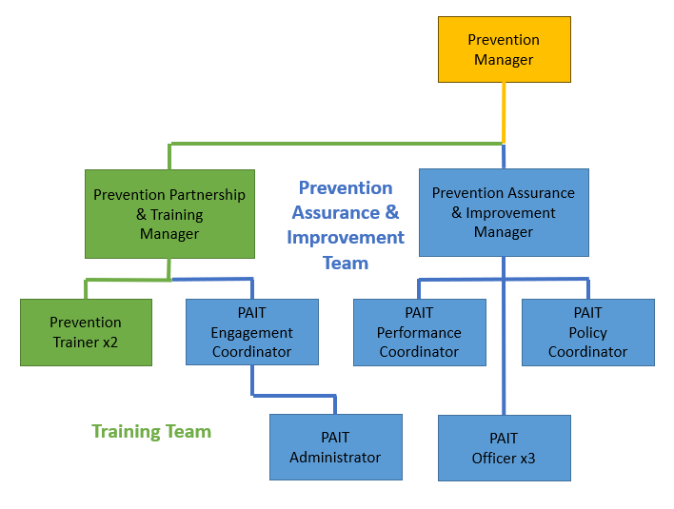

Skills and experience requirements for this role
In the supporting statement section of the application form give clear, concise examples of how you meet all of the Essential person specification criteria (i.e. items you must be able to do from day one to be able to do the job), identified as ‘Application’ in order to be shortlisted for this vacancy. If a large number of applications are received, only those who also meet the Desirable criteria, identified as ‘Application’, will be shortlisted, i.e. criteria you need to do the job, but which could be learnt during training.
Please list or number the competency criteria below against which you are providing evidence/examples in order to structure your supporting statement in a well organised way.
There may be some criteria that are identified through ‘Selection Process’ only. You will only be assessed on these criteria during the selection process and not from your application form, this may involve tests, presentations, interview etc.
 | Experience. | Essential/Desirable. | Where identified.
 | Working knowledge of fire prevention principles and practices to a level that you can provide advice and guidance both on established internal policy and on external regulations or legislation, preferably within the fire and rescue sector or a similar regulated environment. | Essential. | Application & Selection Process.
 | Experience in establishing and managing performance monitoring systems, including designing tools and procedures to accurately track service delivery. | Essential. | Application & Selection Process.
 | Experience in analysing performance data, preparing detailed reports, and providing constructive feedback to support staff development. | Essential. | Application & Selection Process.
 | Experience in developing, implementing, maintaining, and coordinating quality assurance standards within an organisation. This includes ensuring compliance with national guidelines and ensuring there is a standardisation of approach. | Essential. | Application & Selection Process.
 | Experience in undertaking routine training needs analysis to ensure that identified areas for improvement are being implemented and to evaluate the impact of policy change. | Essential. | Application & Selection Process.
 | Demonstrable experience of coaching tactical-level managers within a medium to large organisation, including providing tailored advice and guidance on fire prevention principles and practices. This involves supporting managers to interpret and apply both internal policies and external regulations. | Essential. | Application & Selection Process.
 | Experience of resolving problems or situations which may not be covered by existing rules, procedures, or instructions. | Essential. | Application & Selection Process.
 | Strong background in preparing detailed guidance and reports, and communicating findings and recommendations to support managerial decision-making and staff improvement. | Essential. | Application & Selection Process.
 | Demonstrated ability to interact with service users and facilitate organisational learning initiatives. Experience leading learning processes and collaborating across departments to identify and address service gaps, trends, and communication needs. | Essential. | Application & Selection Process.
 | Experience working collaboratively with various internal and external stakeholders, including staff from different departments, service users, and management to enhance risk reduction and service delivery. | Essential. | Application & Selection Process.
 | Practical experience in day-to-day supervision and tasking of staff, particularly in coordinating the activities of officers or team members. Candidates should have experience acting as a first point of contact for staff, including managing health and safety issues related to lone and out-of-hours working. | Essential. | Application & Selection Process.

 | Education and Training. | Essential/Desirable. | Where identified.
 | Previous formal training to graduate or professional qualification level, or able to demonstrate an equivalent level of learning gained through work experience. | Essential. | Application.
 | Proficiency in Excel and data analysis, with an understanding of database extraction processes, data structures, transformations, and visualisation. | Essential. | Application & Selection Process.
 | Formal training or certification in Power BI (such as Microsoft’s official Power BI certifications). This includes knowledge of DAX, Power Query, report design, and dashboard creation. | Desirable. | Application & Selection Process.
 | A relevant Assessor qualification and experience of designing and implementing quality assurance processes in a medium to large organisation. | Essential. | Application & Selection Process.
 | A relevant Internal Quality Assurance (IQA) qualification. | Desirable. | Application & Selection Process.
 | A relevant coaching qualification and/or experience of the coaching of tactical-level managers in a medium to large organisation. | Essential. | Application & Selection Process.

 | Special knowledge and skills. | Essential/Desirable. | Where identified.
 | Be initiative-taking and prioritise workloads to meet multiple demands (sometimes conflicting), and with minimal supervision. | Essential. | Application & Selection Process.
 | Using creative skills to develop innovative solutions, incorporating ideas or concepts which are previously untried within the sector. | Essential. | Application & Selection Process.
 | Strong interpersonal, communication, and training skills and the ability to work effectively to meet the demanding needs of a wide range of individuals, groups and organisations at different levels. | Essential. | Application & Selection Process.
 | Can demonstrate advisory, guiding, negotiating, persuasive and empathic skills in the development and implementation of a variety of risk reduction activities. | Essential. | Application & Selection Process.
 | Use IT (Microsoft O365, Power BI, Power Apps, Power Automate) proficiently in the collation, analysis and presentation of information, and be able to use a keyboard and/or mouse with both precision and speed. | Essential. | Application & Selection Process.
 | Demonstrate commitment to good data quality within all areas of work. | Essential. | Selection Process only.
 | Demonstrate commitment to and understanding of Equality & Diversity, NFCC Core Code of Ethics and WYFRS values. | Essential. | Selection Process only.
 | To hold and maintain a current full UK valid car driving licence. | Essential. | Application & Selection Process.

Job Description last updated: January 2026

