Safeguarding Policy
  - PRE-POL-002
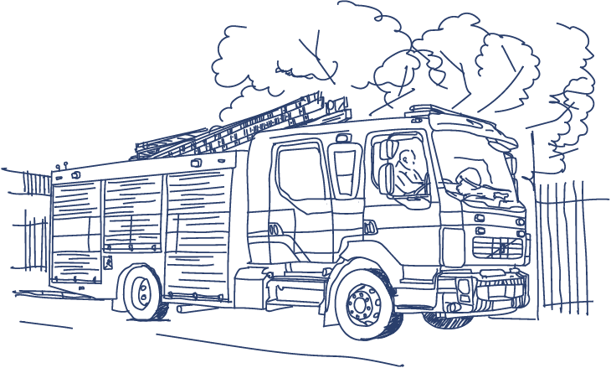
Ownership: PAIT
Date Issued: 01/08/2025
File ID: PRE-POL-002
Version: Version 2
Status: Approved
Protected: OFFICIAL

Contents
Introduction 3
What Is Our Offer? 3
Accessibility 4
Partnerships 4
Data and information sharing 4
Equality and Diversity 5
Monitoring and Review 5
How this policy supports our values 5

Introduction
West Yorkshire Fire and Rescue Service (WYFRS) is committed to safeguarding children and adults at risk from abuse, neglect and self‑neglect. Safeguarding is everyone’s responsibility and applies to all WYFRS staff in the course of their duties.
This policy sets out WYFRS’ commitment to recognising, reporting and responding to safeguarding concerns in line with statutory requirements and local multi‑agency safeguarding arrangements. It supports a person‑centred approach, ensuring individuals are treated with dignity and respect, and that action is taken proportionately to reduce the risk of harm.

What Is Our Offer?
WYFRS will report all situations where a safeguarding issue has taken place, is threatened or where an omission of care has been identified or is suspected.
We will therefore ensure that all our staff are:
- Knowledgeable about how to recognise abuse, neglect and self-neglect.
- Confident about when and how to report those at risk.
We will respond to any cause for concern in line with our Safeguarding Procedure and the ‘Joint Multi-agency Safeguarding Adult’s Policy and Procedures’, West Yorkshire, North Yorkshire and York (2018).
Safeguarding applies to the protection of children and vulnerable adults at risk from abuse and neglect, regardless of whether they live independently or receive formal or informal care. A vulnerable adult is any adult who may be in need of support or care services and is unable to take care of themselves or protect themselves from significant harm or exploitation.
Our decision to raise a cause for concern or safeguarding referral should be made, wherever possible, in conjunction with the person concerned if they have the capacity to contribute to the decision. During our delivery of the identification and reporting of safeguarding cases, we will:

- Ensure individuals are empowered and encouraged to make their own informed decisions.
- Treat individuals fairly and with dignity and respect.
- Take action to prevent harm in a timely manner.
- Act proportionally to the risk presented.
- Be accountable and transparent in our processes.
- Support and represent those in the greatest need.
- Work together in partnership to ensure people are protected from neglect and abuse.
We are a reporting agency only, so no member of staff will investigate any incident of abuse unless they have been designated a specific role as part of a formal safeguarding authority investigation.
Where an adult is not subject to abuse but is at some risk, perhaps due to an element of self-neglect, and may benefit from further engagement with support or care agencies we will, with permission, access suitable support through our existing referral pathways or through direct referrals as appropriate.
We will always report situations where a child’s future health or development may be negatively affected by the situation within which they live. Child protection is part of our safeguarding process; in addition to focussing on protecting individual children who have been identified as experiencing actual harm or abuse we will also take action to report those who are likely to experience harm.
Occasionally, we may see something occurring, or someone may disclose some information, which implies or suggests that someone else is at potential risk of abuse. This abuse may include child sexual exploitation, honour-based violence, human trafficking, intrafamilial abuse, forced marriage, forced labour, domestic servitude and hate crime.
This acquired information, by itself, may not be enough for us to raise a safeguarding cause for concern but, when put together with other information that may be held by our partners, indicates that abuse is taking place or likely to occur. We will share this information with relevant partners as soft intelligence.

Accessibility
Wherever possible, we will seek agreement and permission prior to raising a cause for concern and will be open in our reasons for concern. We will have regard to the person’s views, wishes, feelings and beliefs when deciding on any action, recognising that they may be ambivalent, unclear or unrealistic about their personal circumstances. We will always contact the appropriate emergency service if someone is in immediate danger. Our safeguarding policy is published on our website.

Partnerships
We are represented on each of West Yorkshire’s safeguarding panels and as such are committed to the principles of safeguarding as defined by the Department of Health. We will work together with others to prevent and stop the risks and experience of abuse or neglect arising and to access suitable support when it does. We review our partnerships regularly to ensure the systems and processes in place are effective.

Data and information sharing
Any information gathered by WYFRS staff is recorded electronically and securely at the earliest opportunity. Information is shared on a need-to-know basis both within the organisation and with others. People are able to access their data and information by request in line with current Data Protection legislation.

Equality and Diversity
All WYFRS staff should raise any cause for concern that they become aware of. Our internal safeguarding procedure ensures that all those affected by or subject to a cause for concern are treated fairly and with respect regardless of their faith, disability, gender identity, sexual orientation, or race.

Monitoring and Review
This policy will be reviewed periodically to ensure it remains up to date, effective and aligned with current safeguarding legislation, guidance and multi-agency arrangements.

How this policy supports our values
WYFRS Core Values
- Teamwork: We recognise everyone’s strengths and contributions, working effectively as one team.
- Integrity: We are trustworthy, act ethically, treating each other with dignity and respect.
- Learning: We learn all the time; we share knowledge and experiences, celebrating success.
- Responsibility: We are responsible, work positively and take ownership of the work we do.
- Communication: We share clear information, in ways everyone understands, having open discussions.
Core Code of Ethics for Fire and Rescue Services – our five ethical principles:
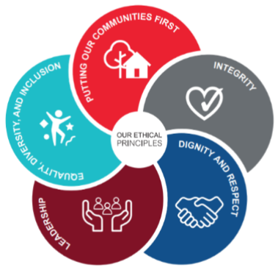
- Putting our communities first: We put the interests of the public, the community, and service users first.
- Integrity: We act with integrity including being open, honest, and consistent in everything that we do.
- Dignity and respect: We treat people with dignity and respect, making decisions objectively based on evidence, without discrimination or bias.
- Leadership: We are all positive role models, always demonstrating flexible and resilient leadership. We are all accountable for everything we do and challenge all behaviour that falls short of the highest standards.
- Equality, diversity, and inclusion (EDI): We continually recognise and promote the value of EDI, both within the FRS and the wider communities in which we serve. We stand against all forms of discrimination, create equal opportunities, promote equality, foster good relations, and celebrate difference.

This policy supports WYFRS values and the Core Code of Ethics in a number of ways, including:

- Putting our communities first: The policy prioritises the protection of children and adults at risk, ensuring safeguarding concerns are identified and reported to protect individuals from harm.
- Integrity: WYFRS commits to acting ethically and transparently. The policy provides clear guidance on recognising, reporting and sharing safeguarding concerns appropriately and lawfully.
- Responsibility: WYFRS takes ownership of its safeguarding responsibilities by ensuring staff are knowledgeable, confident and act proportionately to prevent harm.
- Teamwork: The policy supports effective partnership working with safeguarding agencies, recognising that protecting people from abuse and neglect is a shared responsibility.
Document Properties
Document Title: Safeguarding Policy
Author: PAIT Policy Coordinator
Creation Date: 07 September 2023
Last Updated: 01 August 2025

