West Yorkshire Fire & Rescue Service
  - Job Description.
Post Title: Occupational Health Unit Administrator.
Grade: 2
Responsible To: Senior Occupational Health Advisor.
Purpose Of Post: To provide administration support to the Occupational Health Unit.

Organisational chart.
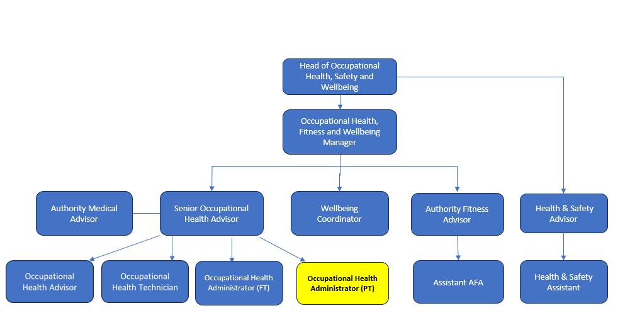

Main duties and responsibilities of the role.
- Reduce the backlog and keep on top of, scanning and uploading of asbestos related documentation.
- Lead on configuring and optimising the Occupational Health database (OPAS G2) to improve system functionality, data quality, and reporting capability; and implement changes both within the unit and across the wider organisation.
- Investigate and deliver efficiencies in the planning and management of Asbestos 3 yearly Medicals.
- Support with streamlining administrative processes, to improve efficiency, reduce duplication, and support a consistent and effective workflow within the Occupational Health Unit.
- Support cover of other admin roles during periods of annual leave.
- Miscellaneous duties.

Organisational wide responsibilities.
- Adherence to the NFCC Core Code of Ethics and West Yorkshire Fire Service Values.

- To implement and promote the Authority’s:
- Health and Safety policies.
- Equality and Diversity policies.
- Information Security Management System policies.
- Safeguarding policies.
- Business continuity policy and contingency arrangements.
- Policies related to General Data Protection Regulation and Data Protection Act 2018.
- Commitment to maintaining our Customer Service expectations.
- A satisfactory Standard Disclosure and Barring check is required for the role.

Skills and experience requirements for this role.
In the supporting statement section of the application form give clear, concise examples of how you meet all of the Essential person specification criteria (i.e. items you must be able to do from day one to be able to do the job), identified as ‘Application’ in order to be shortlisted for this vacancy. If a large number of applications are received, only those who also meet the Desirable criteria, identified as ‘Application’, will be shortlisted, i.e. criteria you need to do the job, but which could be learnt during training.
Please list or number the competency criteria below against which you are providing evidence/examples in order to structure your supporting statement in a well organised way.
There may be some criteria that are identified through ‘Selection Process’ only. You will only be assessed on these criteria during the selection process and not from your application form, this may involve tests, presentations, interview etc.
 | Experience. | Essential/Desirable. | Where identified.
 | Demonstrable experience of providing comprehensive administrative support, preferably within a clinical, occupational health, or similar regulated environment. | Essential. | Application & Selection Process.
 | Proficient in managing high-volume document processing (scanning and uploading) with good accuracy and quality control. | Essential. | Application & Selection Process.
 | Experience of improving administrative processes through identifying and implementing practical, solution-focused changes, and managing projects from start to finish. | Essential. | Application & Selection Process.
 | Proficient in Microsoft Office (especially Word, Outlook and Excel) with strong Excel/database skills and good keyboard skills. | Essential. | Application & Selection Process.
 | Experience of using and maintaining databases, including data entry, configuration, and reporting. | Essential. | Application & Selection Process.
 | Experienced in Microsoft tools such as Planner, Forms and Lists. | Desirable. | Application & Selection Process.
 | Experience with OPAS G2, or other medical database. | Desirable. | Application & Selection Process.

 | Education and Training. | Essential/Desirable. | Where identified.
 | Numeracy and Literacy skills either Level 2 qualifications or GCSE Maths and English Grade A to C or 4 to 9, or an equivalent level of literacy and numeracy gained through work experience. | Essential. | Application & Selection Process.

 | Special knowledge and skills. | Essential/Desirable. | Where identified.
 | Ability to maintain confidentiality (both verbal and written) regarding employee data in line with ethical standards and GDPR. | Essential. | Application & Selection Process.
 | Excellent verbal and written communication skills with ability to communicate with a wide range of people. | Essential. | Application & Selection Process.
 | Excellent attention to detail and organisation skills; ability to work on own initiative, able to plan and prioritise workloads and meet deadlines. | Essential. | Application & Selection Process.
 | Positive, proactive and solution focused, with a commitment to continuous improvement, and the ability analyse and identify opportunities to improve admin processes. | Essential. | Application & Selection Process.
 | Works well independently and in a team. | Essential. | Application & Selection Process.
 | Flexibility to support admin/reception cover during annual leave. | Essential. | Application & Selection Process.
 | Demonstrate commitment to and understanding of Equality & Diversity, NFCC Core Code of Ethics and WYFRS values. | Essential. | Selection Process only.

Job Description last updated: 9th January 2026

