West Yorkshire Fire & Rescue Service
  - Job Description.
Post Title: Occupational Health Unit Administrator/Receptionist
Grade: Grade 2
Responsible To: Senior Occupational Health Advisor
Purpose Of Post: To provide comprehensive reception and administration support to the Occupational Health Unit.

Organisational chart.
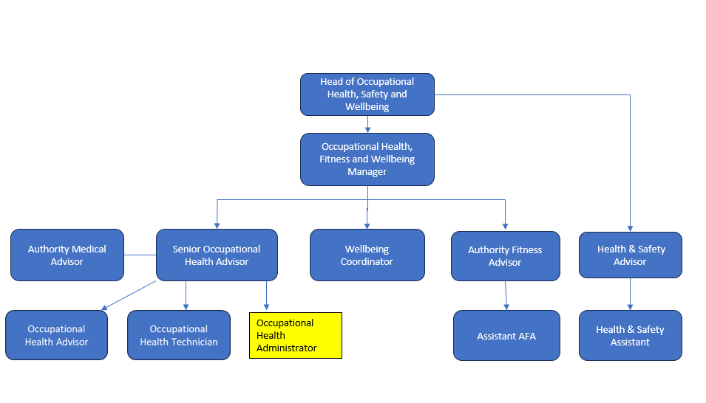

Main duties and responsibilities of the role.
- Obtaining and maintaining documentation for colleagues’ medical records.
- Maintaining data and configuration of the OHU IT system.
- Assisting clinical staff by coordinating and arranging appointments, requesting external information and processing referrals. Ensuring documentation is completed and producing and distributing reports appropriately.
- Perform and administer financial tasks for ordering and payment of goods and services.
- Provide reception and administration duties to help the smooth-running of the department.
- Review and streamline administrative processes, identifying opportunities to improve efficiency, reduce duplication, and support a consistent and effective workflow within the Occupational Health Unit.
- Other admin and miscellaneous duties commensurate with role.

Organisational wide responsibilities.
- Adherence to the NFCC Core Code of Ethics and West Yorkshire Fire Service Values.

- To implement and promote the Authority’s:
- Health and Safety policies.
- Equality and Diversity policies.
- Information Security Management System policies.
- Safeguarding policies.
- Business continuity policy and contingency arrangements.
- Policies related to General Data Protection Regulation and Data Protection Act 2018.
- Commitment to maintaining our Customer Service expectations.
- A satisfactory Standard Disclosure and Barring check is required for the role.

Skills and experience requirements for this role.
In the supporting statement section of the application form give clear, concise examples of how you meet all of the Essential person specification criteria (i.e. items you must be able to do from day one to be able to do the job), identified as ‘Application’ in order to be shortlisted for this vacancy. If a large number of applications are received, only those who also meet the Desirable criteria, identified as ‘Application’, will be shortlisted, i.e. criteria you need to do the job, but which could be learnt during training.
Please list or number the competency criteria below against which you are providing evidence/examples in order to structure your supporting statement in a well organised way.
There may be some criteria that are identified through ‘Selection Process’ only. You will only be assessed on these criteria during the selection process and not from your application form, this may involve tests, presentations, interview etc.
 | Experience. | Essential/Desirable. | Where identified.
 | Demonstrable experience of providing comprehensive administrative support, including general enquiries, liaising with external organisations, obtaining and preparing information, inputting and maintaining data, producing routine statistics and reports, scanning and uploading documents, photocopying, managing a wide range of enquiries across different communication channels and scheduling appointments. | Essential | Application & Selection Process
 | Experience of financial duties e.g. processing purchase orders and invoices, dealing with suppliers, using appropriate budget codes, and ordering stock. | Essential | Application & Selection Process
 | Proficient in the use of Microsoft Office applications (in particular Word, Outlook and Excel) to produce reports, letters, spreadsheets and have good keyboard skills. | Essential | Application & Selection Process
 | Experience in the use of a medical IT system and/or other internal databases, including experience of configuring systems and/or data for reporting purposes | Desirable | Application & Selection Process
 | Experience of providing administrative or reception support within an Occupational Health setting, or similar environment such as a GP surgery, hospital, or other healthcare service, involving confidential information. | Desirable | Application & Selection Process

 | Education and Training. | Essential/Desirable. | Where identified.
 | Numeracy and Literacy skills either Level 2 qualifications or GCSE Maths and English Grade A to C or 4 to 9, or an equivalent level of literacy and numeracy gained through work experience. | Essential | Application & Selection Process

 | Special knowledge and skills. | Essential/Desirable. | Where identified.
 | Ability to maintain confidentiality (both verbal and written) regarding employee data. | Essential | Application & Selection Process
 | Excellent verbal and written communication skills with ability to communicate with a wide range of people. | Essential | Application & Selection Process
 | Excellent organisation skills: ability to work on own initiative, able to plan and prioritise workloads and meet deadlines. | Essential | Application & Selection Process
 | Ability to pay close attention to detail to ensure data and records are accurate and maintained to a high standard. | Essential | Application & Selection Process
 | Ability to work as part of a team. | Essential | Application & Selection Process
 | Demonstrate commitment to and understanding of Equality & Diversity, NFCC Core Code of Ethics and WYFRS values. | Essential | Selection Process only

Job Description last updated: 06/2/26
Content unchanged, JD updated to latest document template.

