West Yorkshire Fire & Rescue Service
  - Job Description.
Post Title: Learning & Development Centre Manager.
Grade: Grade 7
Responsible To: Lead Apprenticeship Manager.
Purpose Of Post:
The Learning and Development Centre Manager will enable a learning, development, and continuous improvement culture at WYFRS. Leading the design, delivery and evaluation of learning projects and programmes and to help ensure our workforce is skilled and equipped to deliver for the communities of West Yorkshire.
Lead on Internal Quality Assurance (IQA) activity, deliver robust systems, processes and implement effective standardisation to maintain excellent qualification and award standards as Centre Manager and Lead IQA.
Managing the learning and development function, including line management of the team, workloads, resource and budget allocation, professional development, and procurement of L&D interventions. Enable a culture of continuous improvement, through project management of key learning and development workstreams, support the delivery of interventions through internal and external provision and evaluate outputs and outcomes.

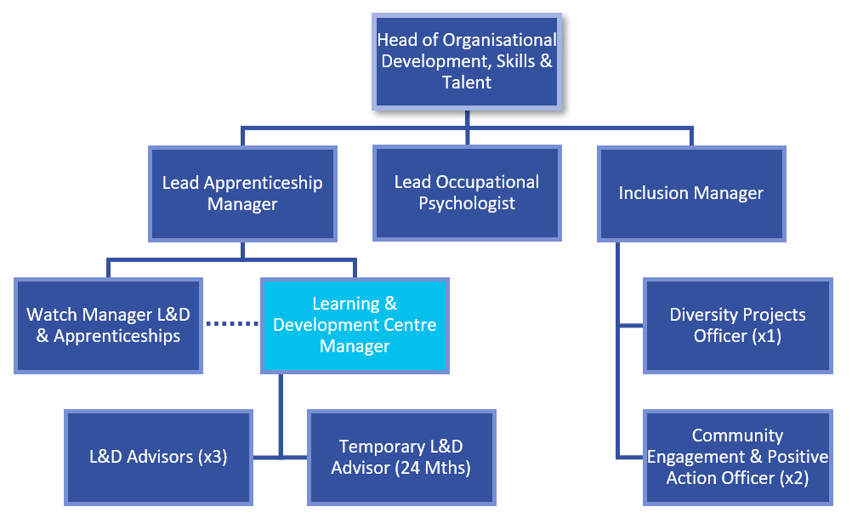
Organisational chart.

Main duties and responsibilities of the role.

Identify, develop, deliver, and evaluate key learning and development projects arising from the organisations CRMP (Community Risk Management Plan and People Strategy. Delivery of streams of work including L&D Course and event plans, Appraisal (Annual Review), Continuous Professional Development (CPD), Coaching, Mentoring, and provision of diagnostics / 360’s.

Line management responsibility for the Learning & Development team, including L&D project management, continuous improvement in assessment and standardisation meetings with Internal Quality Assurers.

To be WYFRS Centre Manager (Skills for Justice) and Lead IQA (Internal Quality Assurance); managing awarding body relationships, maintaining WYFRS awarding body centre approval and oversight of internal and external quality standards, regulatory requirements, certification, and Awarding Body quality assurance systems. Maintain Learning & Development / Assessment policies and strategy documents.

Responsible for managing identified learning and development budgets, managing relationships and quality with internal and external providers of West Yorkshire Fire & Rescue Service (WYFRS) learning and development programmes. Responsible for development and delivery of self-development, team, manager, and leadership resources, including content for internal online channels.

Act as the Authority lead on examinations, including assurance of registration and delivery of examinations in line with the requirements of the awarding body examinations acting as Head Invigilator for IFE (Institute of Fire Engineer) taking responsibility for the security and integrity of any examinations hosted by or on behalf of WYFRS.

Management of promotion and development portfolios, programmes, and content for Operational and Enabling teams, including oversight of on station support, continuous improvement, and quality assurance.

Lead the service response and coordinate with the Awarding Body EQA (External Quality Assurance) to meet the requirements of external qualification / awarding body audits.

Organisational wide responsibilities.
- Adherence to the NFCC Core Code of Ethics and West Yorkshire Fire Service Values.
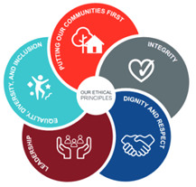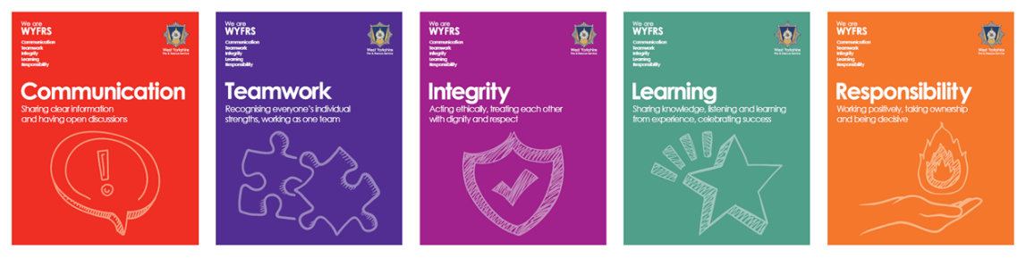
- To implement and promote the Authority’s:
- Health and Safety policies.
- Equality and Diversity policies.
- Information Security Management System policies.
- Safeguarding policies.
- Business continuity policy and contingency arrangements.
- Policies related to General Data Protection Regulation and Data Protection Act 2018.
- Commitment to maintaining our Customer Service expectations.
- A satisfactory Standard Disclosure and Barring check is required for the role.
- This post has been designated a hybrid working post which means the postholder’s working time will be split between the workplace and home. The actual pattern and number of days at each will be agreed locally with the line manager and will be determined based on the service needs.

Skills and experience requirements for this role
In the supporting statement section of the application form give clear, concise examples of how you meet all of the Essential person specification criteria (i.e. items you must be able to do from day one to be able to do the job), identified as ‘Application’ in order to be shortlisted for this vacancy. If a large number of applications are received, only those who also meet the Desirable criteria, identified as ‘Application,’ will be shortlisted, i.e. criteria you need to do the job, but which could be learnt during training.
Please list or number the competency criteria below against which you are providing evidence/examples in order to structure your supporting statement in a well organised way.
There may be some criteria that are identified through ‘Selection Process’ only. You will only be assessed on these criteria during the selection process and not from your application form, this may involve tests, presentations, interview etc.
 | Experience. | Essential/Desirable. | Where identified.
 | Significant experience in the identification, development, delivery and evaluation of learning and development programmes within an organisation. | Essential. | Application / Assessment/ Interview.
 | Experience of line management of a team, including allocating and management of individual / team / organisational priorities and projects, setting, and achieving team goals and holistic performance management. | Essential. | Application / Assessment/ Interview.
 | Experience in mapping and implementing occupational standards against qualifications | Essential. | Application / Assessment/ Interview.
 | Experience of managing budgets, including purchase order management monitoring of spend against budget. | Essential. | Application / Assessment/ Interview.
 | Demonstrable experience of facilitating change through learning and development interventions, setting achievable outcomes, delivery, measurement, and evaluation of impacts. | Essential. | Application / Assessment/ Interview.
 | Experience of delivering continuous improvement through development of service objectives, policies, procedures, and process mapping. | Essential. | Application / Assessment/ Interview.
 | Experience of maintenance of Awarding Body Approved Centre Status. | Desirable. | Application / Assessment/ Interview.
 | Experience of commissioning training providers, negotiating with providers to achieve engaging content and value for money. | Desirable. | Application / Assessment/ Interview.

 | Education and Training. | Essential/Desirable. | Where identified.
 | Good level of Literacy and Numeracy, (Level 2 / GCSE Maths and English Grade 4 / C or above or equivalent qualifications). | Essential. | Application.
 | Educated to degree level (Level 6) or able to demonstrate an equivalent level of learning gained through experience. | Essential. | Application.
 | IQA Verifier Qualification / demonstrable experience of embedding quality assurance in a learning / qualification environment | Essential. | Application / Interview.
 | Level 5 Coaching / Mentoring Qualification | Desirable. | Application.

 | Special knowledge and skills. | Essential/Desirable. | Where identified.
 | Knowledge of Awarding Body Codes of Practice and Assessment Strategies | Essential. | Application / Interview.
 | Demonstrable skills and knowledge of delivering interactive and engaging learning and development content to groups in person or online | Essential. | Application / Assessment / Interview.
 | Ability to manage difficult and challenging situations assertively, maintain confidentiality and use discretion, tact, and sensitivity. | Essential. | Application / Assessment / Interview.
 | Skills to guide, support, advise and influence people at all levels who are outside of your line management area. E.g. to enforce centre standards and address compliance issues with more senior managers. | Essential. | Interview.
 | Knowledge and skills to make decisions using data, including collation, analysis and presentation of results and recommendations. | Essential. | Application / Assessment.
 | Knowledge and skills to lead the work of a team, including work setting and managing work plans to achieve short and long term outcomes. | Essential. | Application / Assessment / Interview.
 | Knowledge and skills in the use of Microsoft Office (or equivalent), specifically Presentations, spreadsheets, data analysis and word processing. | Essential. | Assessment / Interview.
 | High level of written and verbal communication skills, for example to write compelling business reports and present the findings effectively. | Essential. | Assessment / Interview.
 | Excellent organisation and time Management skills, including juggling conflicting deadlines and prioritising work of self and team. | Essential. | Application / Assessment / Interview.
 | Coaching or mentoring knowledge and skills. | Essential. | Application / Interview.
 | Demonstrates commitment to taking a leading role in driving forward WYFRS’ commitment to Equality & Diversity, NFCC Core Code of Ethics and WYFRS values. | Essential. | Application / Assessment / Interview.
 | To hold and maintain a current full UK valid car driving licence. | Essential. | Application.
 | Experience of working autonomously and taking a lead as Centre Manager for awarding bodies and when negotiating with training providers. | Desirable. | Application / Assessment / Interview.

Job Description last updated: March 2025

