West Yorkshire Fire & Rescue Service
  - Job Description.
Post Title: Data Analyst.
Grade: 7.
Responsible To: Data Team Manager.
Purpose Of Post: To ensure the effective delivery and management of data analysis and reporting services within the Authority. The role focuses on developing and maintaining Power BI dashboards, analysing organisational data and supporting decision-making processes. The post holder will help the Fire and Rescue Authority achieve its objectives by providing high-quality data insights and technical support to various departments.

Organisational chart.

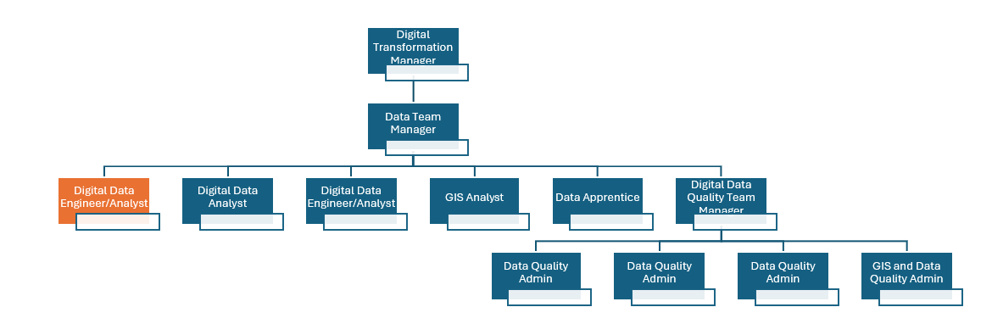

Main duties and responsibilities of the role.
- Data Analysis (SFIA: Data Analysis, Level 5)
- Develop, maintain and optimise Power BI dashboards and reports tailored to organisational needs.
- Analyse data to identify trends, issues and opportunities, providing clear recommendations to support decision-making.
- Transform reporting requirements into meaningful visualisations and data stories.

- Data Development (SFIA: Database Design, Level 5)
  - Ensure data visualisations are clear, accurate and actionable for a range of audiences.
  - Work proactively with departments and stakeholders to identify, access and gather data from a variety of sources.
  - Design, build and support maintenance databases and dataflows to ensure data is structured, accurate and ready for analysis.
  - Support the end-to-end process of sourcing, cleaning and preparing data for reporting and analysis.

- Data Management (SFIA: Solution Development, Level 5)
  - Ensure data quality, accuracy and compliance with relevant policies (e.g., GDPR, Data Protection Act).
  - Build and maintain dataflows and reusable datasets.
  - Create and maintain documentation for data processes and reports.

- Collaboration (SFIA: Collaboration and Operation, Level 4)
  - Work closely with colleagues and stakeholders to understand data and reporting requirements.
  - Support the implementation of new approaches and processes.
  - Provide technical advice and training to users as required.

- Technical Support (SFIA: Technical Support, Level 3)
- Take ownership of complex data queries and ensure timely resolution.
- Advise and support staff in the use of data tools and reporting solutions.

- External Liaison (SFIA: Stakeholder Management, Level 4)
- Develop and maintain relationships with relevant external partners to support data sharing and best practice.
- Develop and manage relationships with data owners and subject matter experts to understand business processes and data requirements.

Organisational wide responsibilities.
- Adherence to the NFCC Core Code of Ethics and West Yorkshire Fire Service Values.
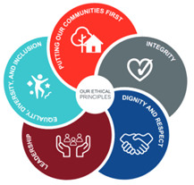

- To implement and promote the Authority’s:
- Health and Safety policies.
- Equality and Diversity policies.
- Information Security Management System policies.
- Safeguarding policies.
- Business continuity policy and contingency arrangements.
- Policies related to General Data Protection Regulation and Data Protection Act 2018.
- Commitment to maintaining our Customer Service expectations.
- A satisfactory Standard Disclosure and Barring check is required for the role.
- This post has been designated a hybrid working post which means the postholder’s working time will be split between the workplace and home. The actual pattern and number of days at each will be agreed locally with the line manager and will be determined based on the service needs.

Skills and experience requirements for this role
In the supporting statement section of the application form give clear, concise examples of how you meet all of the Essential person specification criteria (i.e. items you must be able to do from day one to be able to do the job), identified as ‘Application’ in order to be shortlisted for this vacancy. If a large number of applications are received, only those who also meet the Desirable criteria, identified as ‘Application’, will be shortlisted, i.e. criteria you need to do the job, but which could be learnt during training.
Please list or number the competency criteria below against which you are providing evidence/examples in order to structure your supporting statement in a well organised way.
There may be some criteria that are identified through ‘Selection Process’ only. You will only be assessed on these criteria during the selection process and not from your application form, this may involve tests, presentations, interview etc.
 | Experience. | Essential/Desirable. | Where identified.
 | Technical experience and specialist knowledge in data analysis and reporting tools (e.g., Power BI, SQL). | Essential. | Application & Selection Process.
 | Experience of working with data modelling tools, utilising business intelligence reporting tools and analysis | Essential. | Application & Selection Process.
 | Experience in producing reports for key strategic decision making. | Essential. | Application & Selection Process.
 | Experience of working in the public sector, preferably a blue light service, and previous experience of working with ordnance survey data. | Desirable. | Application.

 | Education and Training. | Essential/Desirable. | Where identified.
 | Qualification or education in a relevant area or equivalent experience. | Essential. | Application & Selection Process.
 | Qualification in SQL or equivalent experience to be able to query, extract and load data sets. | Essential. | Application & Selection Process.

 | Special knowledge and skills. | Essential/Desirable. | Where identified.
 | Excellent problem-solving and analytical skills, with a keen eye for data quality. | Essential. | Application and Selection Process.
 | Effective communication and collaboration abilities. Ability to explain complex information clearly to a range of audiences. | Essential. | Application and Selection Process.
 | Strong technical skills in data modelling and analysis. | Essential. | Application and Selection Process.
 | Demonstrate commitment to good data quality within all areas of work. | Essential. | Application and Selection Process.
 | Demonstrate commitment to and understanding of Equality & Diversity, NFCC Core Code of Ethics and WYFRS values. | Essential. | Selection Process only.
 | To hold and maintain a current full UK valid car driving licence. | Essential. | Application & Selection Process.

Job Description last updated: April 2025.

