West Yorkshire Fire & Rescue Service
  - Job Description.
Post Title: Fire Protection Inspector.
Grade: Grade 7 + 7% market supplement.
Responsible To: Fire Protection Supervisor.
Purpose Of Post: To assist the Fire Authority in the discharge of its fire protection duties and responsibilities.

Organisational chart.

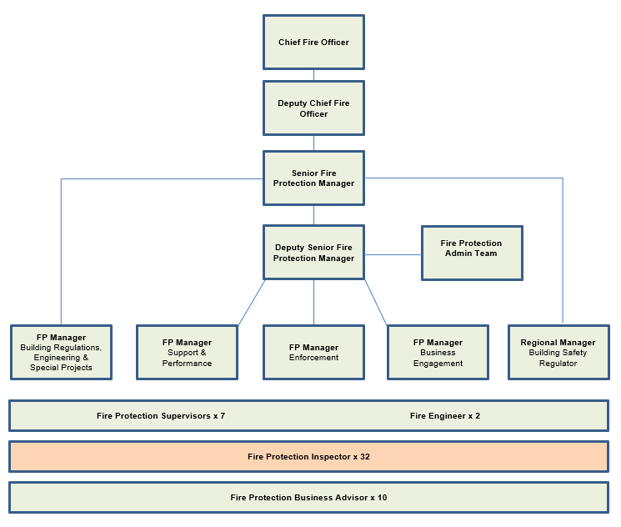

Main duties and responsibilities of the role.
First Area:-
1.1 Delivery of service objectives by utilising advanced theoretical, practical, and procedural knowledge to successfully carry out fire protection audits, inspections, and consultations in all categories of premises including complex high-risk premises, under legislation enforced by the Fire & Rescue Authority.
1.2 Identify fire protection compliance issues during audit, inspection and consultation and implement and advise on analytical and judgemental ways to determine appropriate solutions or strategies to reduce the risk to life from fire.
1.3 Work (independently) with a high degree of autonomy within policy and procedure guidelines whilst utilising a wide level of initiative when dealing with identifying and suggesting solutions to fire protection problems that will impact upon the long-term safety of the general population of West Yorkshire.
1.4 Undertake enforcement action in line with policy and procedures by preparing and issuing statutory legal fire protection notices, reports, and letters independently whilst following service policy and supporting the principles detailed in the Regulators Code.
1.5 Utilise highly developed and advanced influencing and negotiating skills to ensure that those responsible for the safety of others take appropriate action they may not otherwise wish to take, whilst working within the constraints of the Regulators Code.
1.6 Liaise with other enforcing authorities and local authorities on safety critical matters that may require immediate action to safeguard the safety of relevant people and subsequently the re-housing of displaced occupants where prohibition is necessary.
1.7 Develop, co-ordinate and input sensitive and confidential information into the Authority’s Protection database and associated systems to maintain a robust audit trail and promote the sharing of critical safety information that will contribute to ensuring the safety of firefighters at operational incidents, whilst maintaining a high level of precision and data accuracy of recorded information.
1.8 To represent the Fire & Rescue Authority at fire protection meetings both internally and with other agencies involved in the safety of occupants, building design or construction.
1.9 To publicise and promote fire protection amongst the public and provide fire protection and arson reduction advice to the communities of West Yorkshire.
1.10 Initiate prosecution investigations where offences have put relevant people at risk of death or serious injury in case of fire and where necessary, provide support to the investigation of an offence through the preparation of case files. This includes the carrying out of PACE interviews, cautioning of witnesses, taking, and preparing statements and the collecting of evidence and giving evidence at a tribunal/court as a technical/professional witness or representative of the Fire Authority.
1.11 To investigate complaints/offences contrary to legislation where relevant persons are put at risk of death or serious injury enforced by the Fire Authority and assist with the preparation of investigation reports.
1.12 Communicate skills and knowledge to colleagues in order to support, train and mentor their personal and professional development and enhance the safety, efficiency, and effectiveness of the Fire Protection team.
1.13 To establish and maintain productive working relationships with colleagues and contacts external to the Fire Authority including liaison with other enforcing authorities throughout the 5 districts of West Yorkshire and government bodies on fire safety matters covered by existing protocols.
1.14 Work within the constraints of better regulation under the Primary Authority Scheme and understand the statutory processes required between WYFRS and other Fire and Rescue Services.
1.15 To understand the principles of the prevention and mitigation of fire and to communicate this to service users in a simple, logical, and cost-effective manner.
1.16 Deliver Fire Protection training and Topic Talks to operational personnel and act as FP Liaison Officer to station providing feedback on fire safety matters to operational crews relating to Operation Risk Visits.
1.17 Maintain knowledge and understanding of Fire Protection policies and procedures and relevant current legislation, codes of practice and other related technical fire safety matters.
1.18 Attend departmental meetings, training sessions, and courses identified as appropriate to the current role which may involve attendance on external courses at providers such as the Fire Service College.
1.19 To undertake any other fire protection duties as directed by the Fire Protection Managers commensurate with the grade.
1.20 Identify conditions where the public are put at risk of death or serious injury in case of fire and inform the relevant authorised officer and assist with prohibition or restriction as necessary under article 31 of the RR(FS) O 2005.
1.21 Assist WYFRS carry out its duties as an employer under the Fire Safety Order by supporting Station Commanders in carrying out fire risk assessment for WYFRS premises.
1.22 To carry out surveillance work in line with Regulation of Investigatory Powers Act 2000 (RIPA), if required.
1.23 Support the Explosives Team by carrying out annual inspections of premises storing and retailing explosives under the Explosives Regulations 2014 having detailed knowledge and understanding of the principles of firework storage.

Second Area:-
2.1 To implement and promote the Authority’s:
  - Fire Protection policy
  - Equality and Diversity Policies
  - Health and Safety policies
  - Information Security Management System polices
  - Safeguarding Children & Vulnerable People Policy

2.2 Responsibility to ensuring any data produced in relation to the post is accurate and current.
2.3 To undertake any Fire Protection projects as directed by line management.

Organisational wide responsibilities.
- Adherence to the NFCC Core Code of Ethics and West Yorkshire Fire Service Values.

- To implement and promote the Authority’s:
- Health and Safety policies.
- Equality and Diversity policies.
- Information Security Management System policies.
- Safeguarding policies.
- Business continuity policy and contingency arrangements.
- Policies related to General Data Protection Regulation and Data Protection Act 2018.
- Commitment to maintaining our Customer Service expectations.
- A satisfactory Standard Disclosure and Barring check is required for the role.
- This post has been designated a hybrid working post which means the postholder’s working time will be split between the workplace and home. The actual pattern and number of days at each will be agreed locally with the line manager and will be determined based on the service needs.

Skills and experience requirements for this role
In the supporting statement section of the application form give clear, concise examples of how you meet all of the Essential person specification criteria (i.e. items you must be able to do from day one to be able to do the job), identified as ‘Application’ in order to be shortlisted for this vacancy. If a large number of applications are received, only those who also meet the Desirable criteria, identified as ‘Application,’ will be shortlisted, i.e. criteria you need to do the job, but which could be learnt during training.
Please list or number the competency criteria below against which you are providing evidence/examples in order to structure your supporting statement in a well organised way.
There may be some criteria that are identified through ‘Selection Process’ only. You will only be assessed on these criteria during the selection process and not from your application form, this may involve tests, presentations, interview etc.
 | Experience. | Essential/Desirable. | Where identified.
 | Proven practical experience in the application of fire protection legislation to effectively solve fire protection problems. | Essential. | Application Form.
 | Competent at carrying out fire protection ‘risk assessments,’ or equivalent competency as a Health and Safety Inspector. | Essential. | Selection Process.
 | Involvement in the issue of Improvement, Alterations, and/or Enforcement Notices. | Essential. | Application Form.
 | Ability to communicate effectively with individuals and groups, ranging from works and installation engineers to senior executives and other professionally qualified experts such as structural engineers and architects. | Essential. | Selection Process.
 | Possess sufficient practical experience to effectively deliver fire protection services. | Essential. | Selection Process.
 | Have experience at leading discussions involving innovative thinking, and problem solving. | Essential. | Application Form.
 | Have experience of working as part of a team, having commitment and flexibility in personal working hours to meet objectives. | Essential. | Application Form.

 | Education and Training. | Essential/Desirable. | Where identified.
 | NFCC Competence Framework Level 4 Diploma Fire Inspector Qualification or equivalent. or  Either successfully achieved NVQ Level 3 in Legislative Fire Safety or NEBOSH Certificate in Fire Safety, or  Successfully completed the WYF&RS development workbook to Inspector level | Essential. | Application Form.
 | 2 x IFE Level 3 Certificate Examination papers or equivalent.  A pass in the Fire Engineering Science paper plus a pass in one other paper | Desirable. | Application Form.
 | BTEC Diploma in Advanced Investigative Practice Level 7 or equivalent | Essential. | Selection Process.
 | Good standard of education including Maths and English at GCSE Grade C (Level 4) or above, or equivalent qualification or demonstratable work experience. | Essential. | Application Form.

 | Special knowledge and skills. | Essential/Desirable. | Where identified.
 | Support the delivery of the Fire Protection Risk Based Inspection Programme by working flexibly to the needs of the post and the service, which may on occasions involve the completion of work beyond core hours. | Essential. | Selection Process.
 | Be able to define the legislative framework and the mechanisms of enforcement of fire protection in all categories of new, altered, and existing buildings. | Essential. | Selection Process.
 | Be able to define the consultation procedures relating to the fire protection elements of current Building Regulations. | Essential. | Selection Process.
 | Fully understand the generic principles of means of escape and fire protection and have an appreciation of their development. | Essential. | Selection Process.
 | Understand the principles and the role in life safety of, fire detection and alarm systems emergency lighting systems firefighting equipment and fire protection signs and notices. | Essential. | Selection Process.
 | Understand the importance of fire protection management in protection of people from fire. | Essential. | Selection Process.
 | Understand the facilities necessary to assist the fire service in protection of people (including fire fighters) from fire. | Essential. | Selection Process.
 | Be able to demonstrate a clear understanding of, and be able to distinguish between, the concepts of fire hazard and fire risk | Essential. | Selection Process.
 | Be able to conduct fire risk assessments of buildings and recognise the various methodologies of risk assessment. | Essential. | Selection Process.
 | Be able to demonstrate an awareness of cost benefit analysis to ensure that fire protection works required are proportionate to the costs incurred. | Essential. | Selection Process.
 | Understand the limitations of prescriptive codes and understand the use of fire risk assessment to justify departures from prescriptive codes. | Essential. | Selection Process.
 | Be able to demonstrate a thorough knowledge of the causes of fire, and of the significance of the common causes in different occupancies. | Essential. | Selection Process.
 | Be able to evaluate the elements enlisted in a defence against fire to ensure they fully integrate with likely human performance/behaviour. | Essential. | Selection Process.
 | Understand his or her limitations in the field of fire protection, and the need to involve further senior or specialist’s officers on occasions. | Essential. | Application Form.
 | Ability to deliver safety information to a wide range of audiences including Operational personnel and be able to convey complex information in a clear and logical manner. | Essential. | Selection Process.
 | Be self-motivated and prioritise work directed to achieve targets within tight deadlines and with minimal supervision. | Essential. | Selection Process.
 | Use IT software and systems to effectively and accurately collate, record, analyse and present information. | Essential. | Selection Process.
 | Demonstrate commitment to good data quality within all areas of work. | Essential. | Selection Process.
 | Have an understanding of the different social and environmental issues of the local communities within West Yorkshire. | Essential. | Selection Process.
 | Ability and Skill to deliver FP training to operational personnel | Essential. | Selection Process.
 | Demonstrate commitment to and understanding of Equality & Diversity, NFCC Core Code of Ethics and WYFRS values. | Essential. | Selection Process.
 | To hold and maintain a current UK driving licence. | Essential. | Application Form.

Job Description last updated: 19 November 2025.

