WEST YORKSHIRE FIRE & RESCUE SERVICE

JOB DESCRIPTION

POST TITLE: | Senior Finance Business Partner
GRADE: | Grade 8
RESPONSIBLE TO: | Financial Accountant
PURPOSE OF POST: | The primary objective of this role is to oversee the provision of accurate, understandable and timely financial information as well as the preparation of the Authority’s financial accounts. Additionally this role involves acting as the Authority’s critical friend by challenging internal processes and managing risk by ensuring compliance with legislation and financial regulations. The Senior Finance Business Partner will also influence, develop, and implement financial strategies, projects, initiatives, and procedures to ensure that financial goals are aligned with organizational goals and objectives.
ORGANISATION CHART:
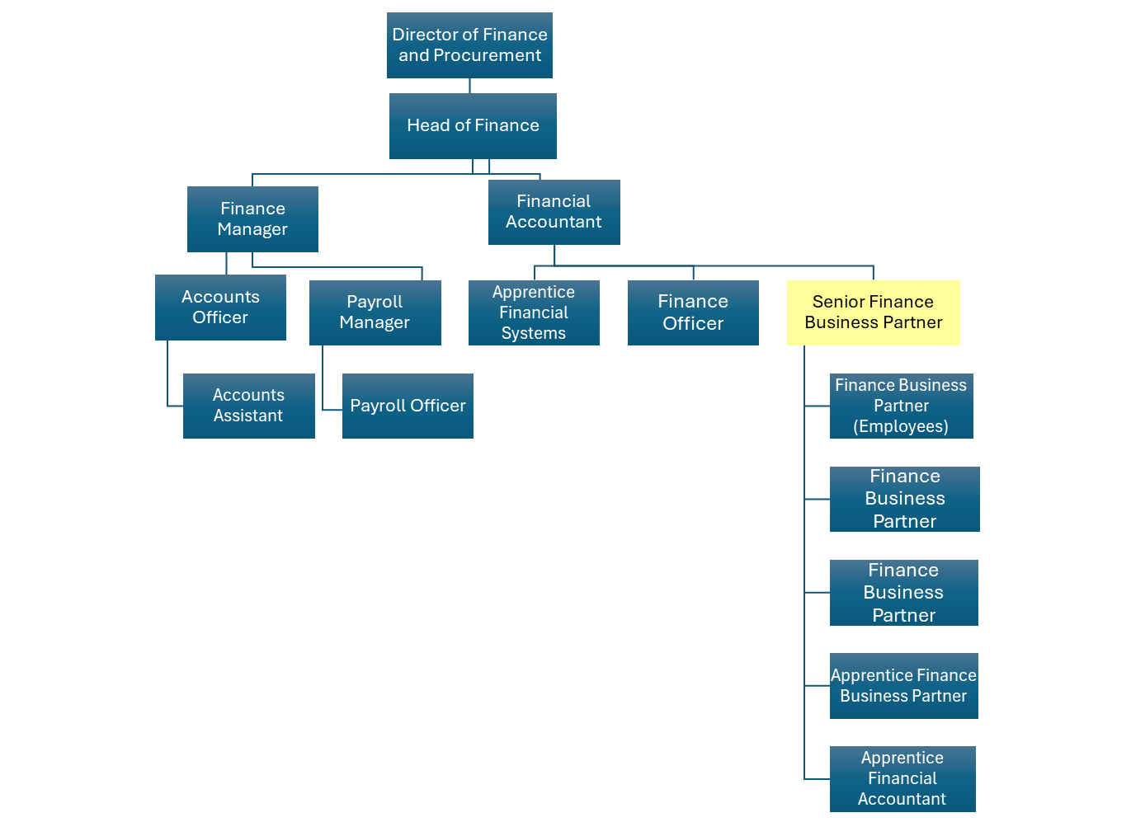

MAIN DUTIES AND RESPONSIBILITIES OF THE ROLE

- Management Accounting
- Oversee and co-ordinate the provision of budget monitoring information (Capital and Revenue) on a monthly basis ensuring that expenditure is accurate and that the information is in an easy to understand format.
- Lead the development and maintenance of monitoring reports, including the introduction of automated processes, that enables the Authority to maintain budgetary control in liaison with the Head of Finance.
- Lead on the preparation of the annual budget and ensure that the deadlines for completion are met by the Finance Business Partners.
- Provide training to managers on financial procedures and ensure the adherence to these.
- Co-ordinate the provision of financial information to support the HMICFRS inspection programme

- Financial Accounting
- To assist the Financial Accountant with the production of the Statement of Accounts and the co-ordination of the external audit, including the production of key financial statements and supporting notes to the Statement of Accounts, ensuring that statutory deadlines are strictly adhered to.
- Ensure that changes to CIPFA accounting code of practice are incorporated into the working papers and financial statements and that the accounts are presented in accordance with statutory requirements.
- Assist the Financial Accountant in the management and provision of management information in respect of the Authority’s reserves.
- Working under time pressured conditions to ensure adherence to strict deadlines for the themselves and the team.

- Treasury Management
- Approval of Treasury Management daily dealing activities, including authorising the payment of monies to counterparties from the Authority’s bank account
- Reconciliation of bank statements and balance sheet control accounts.
- To assist the Finance Manager in the preparation of the Authority’s cashflow with respect to capital and revenue forecast expenditure profiles.
- Calculation of capital financing charges budgets and maintenance of systems to enable the accurate monitoring of capital financing charges and the impact on the revenue budget of future capital programs.

- Managing Risk
- Build effective working relationships with staff at all levels to support their understanding of financial regulations and enable delivery of a robust and transparent financial practice.
- In conjunction with the Head of Finance develop Finance policies in line with changes to taxation legislation and statutory requirements.
- Continuously review Finance policies to ensure compliance with current legislation and statutory requirements, liaising with the Authority’s tax advisors, CIPFA and undertaking CPD to ensure knowledge is accurate and up to date.
- Assess the impact and financial implications of any changes in legislation for review by the Head of Finance.
- Lead and coordinate the submission of accurate and timely statutory returns in accordance with strict statutory deadlines, including the Whole of Government Accounts, VAT returns, Capital and Revenue expenditure returns.

- Continuous Improvement
- Continuously review all Finance systems and processes ensuring they are customer focussed, streamlined, efficient and fit for purpose.
- Lead Finance team projects and initiatives. Co-ordinate, prioritise and manage internal transformational activities.
- Represent the Finance Department in organisational project teams to support change initiatives.
- Support the Head of Finance with the Finance team operational planning and the self-assessment processes.
- Development, implementation and review of Key Performance Indicators (KPIs), acting on long term trends / variation to improve operating efficiency and output quality through effective strategies for the issuing of payments to suppliers.
- Provide effective leadership across the department, being responsible for promoting and upholding the culture and values of the organisation and developing the leadership potential of team members through ongoing training, evaluation and coaching.

ORGANISATIONAL WIDE RESPONSBILITIES:

- Adherence to the Core Code which sets out five ethical principles, based on the Seven Principles of Public Life.


- To Implement and promote the Authority’s:
- Health and Safety policies.
- Equality and Diversity policies.
- Information Security Management System policies.
- Safeguarding policies.
- Business continuity policy and contingency arrangements.
- Policies related to General Data Protection Regulation and Data Protection Act 2018 .
- Commitment to maintaining our Customer Service expectations.

SKILLS AND EXPERIENCE REQUIREMENTS FOR THIS ROLE.

In the supporting statement section of the application form give clear, concise examples of how you meet all of the Essential person specification criteria (i.e. items you must be able to do from day one to be able to do the job), identified as ‘Application’ in order to be shortlisted for this vacancy. If a large number of applications are received, only those who also meet the Desirable criteria, identified as ‘Application’, will be shortlisted, i.e. criteria you need to do the job, but which could be learnt during training.

Please list or number the competency criteria below against which you are providing evidence/examples in order to structure your supporting statement in a well organised way.

There may be some criteria that are identified through ‘Selection Process’ only. You will only be assessed on these criteria during the selection process and not from your application form, this may involve tests, presentations, interview etc.

 | Experience. | Essential/ Desirable. | Where Identified.
 | Extensive knowledge of financial procedures and systems relevant to a public sector organisation. | Essential | Application \ Selection Process
 | Extensive knowledge of managing local government budgeting and accounting systems on both revenue and capital expenditure. | Essential | Application \ Selection Process
 | Preparation of detailed financial reports for committees, management board and budget holders | Essential | Application \ Selection Process
 | Ability to understand and explain highly complex financial information to a range of audiences | Essential | Application \ Selection Process
 | Experience of treasury management in a large organisation. | Desirable | Application \ Selection Process
 | Development and improvement of financial systems. | Essential | Application \ Selection Process
 | Extensive experience of the production of the Statement of Accounts for a large organisation | Essential | Application \ Selection Process

 | Education and Training. | Essential/ Desirable | Where Identified.
 | Qualified CCAB accountant. | Essential | Application
 | Evidence of continuing professional and personal development including current membership of a professional accounting body. | Essential | Application

 | Special Knowledge and Skills. | Essential/ Desirable. | Where Identified.
 | Extensive knowledge of accounting codes of practice, accounting conventions and accounting standards and experience in their application. | Essential | Selection Process
 | Appreciation of the current issues that are affecting the fire service and local government in general and a good understanding of how these issues affect the provision of financial management within the fire service. | Desirable | Selection Process
 | Excellent communication, presentation and people skills at all levels within the organisation. | Essential | Application \ Selection Process
 | Ability to prioritise own work and the work of others. | Essential | Selection Process
 | Ability to work under your own initiative ensuring a culture of continuous improvement is adopted through effective decision making. | Essential | Application \ Selection Process
 | Ability to deal with conflicting priorities. | Essential | Application \ Selection Process
 | Ability to translate complex financial information and explain the results to non-financially trained managers. | Essential | Application \ Selection Process
 | Excellent IT skills to enable the preparation of complex financial reports. | Essential | Application \ Selection Process
 | Well developed analytical and problem solving skills. Ability to analyse and make judgement on complex financial information and to develop long term solutions based on the financial analysis. | Essential | Application \ Selection Process
 | Ability to develop the financial expertise of service managers. | Essential | Application \ Selection Process
 | An understanding of the democratic processes of policy within local government. | Desirable | Selection Process
 | Ability to plan, manage and implement projects. | Essential | Selection Process

Job Description: Last updated: 12/08/25

