West Yorkshire Fire & Rescue Service
  - Job Description.
Post Title Service Improvement and Assurance Team (SIAT) Co-Ordinator
Grade: 4
Responsible To: Service Improvement and Assurance Team Manager
Purpose Of Post: To undertake assurance and improvement duties for WYFRS to
support continuous improvement. Provide ICT and administrative support for the team.

Organisational chart.
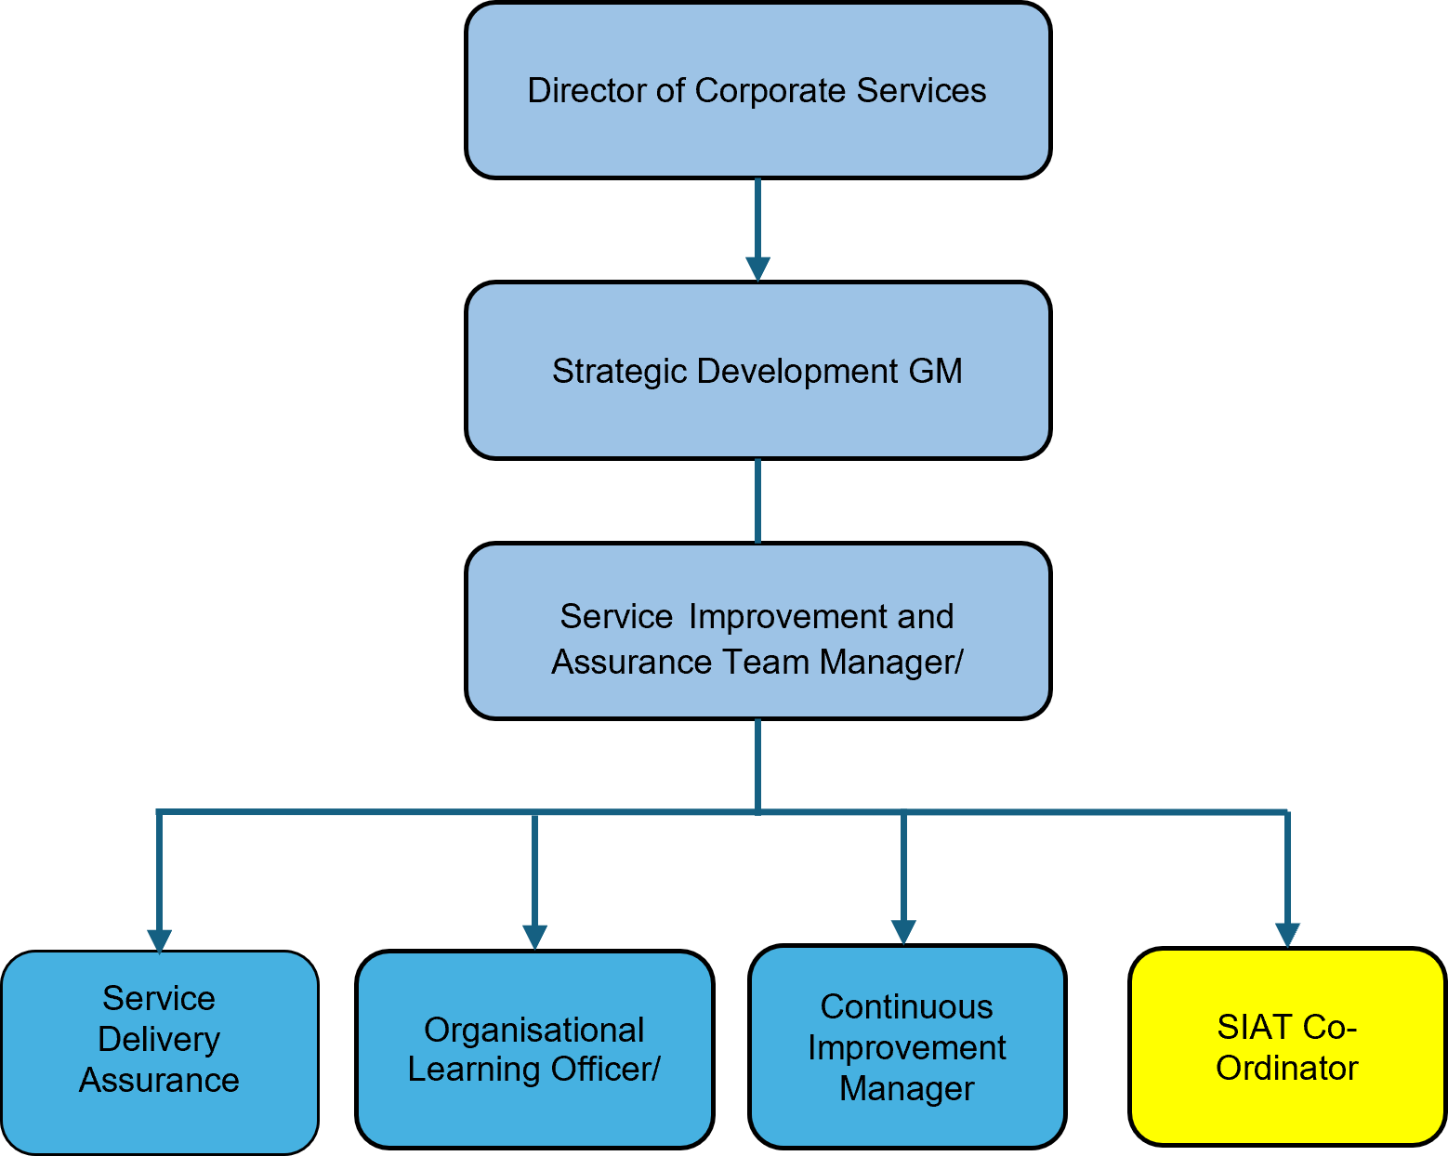

Main duties and responsibilities of the role.
- Support the Service Improvement and Assurance Team manager in the development and delivery of WYFRS internal quality assurance Fire Standards, HMICFRS and Organisational Learning processes.
- Provide advice and guidance to managers re: service assurance, Fire Standards, HMICFRS and Organisational Learning.
- Collect, scrutinise and analyse data and evidence from various sources to find route cause of problems in relation to service improvement, where necessary, advise, guide and challenge.
- Assist with evidence gathering for evaluation and organisational learning processes and produce reports to share findings.
- Contribute to the development of team workflows through introduction of ICT products/systems
- Provide admin support for audit and inspection processes.

Organisational wide responsibilities.
- Adherence to the NFCC Core Code of Ethics and West Yorkshire Fire Service Values.

- To implement and promote the Authority’s:
- Health and Safety policies.
- Equality and Diversity policies.
- Information Security Management System policies.
- Safeguarding policies.
- Business continuity policy and contingency arrangements.
- Policies related to General Data Protection Regulation and Data Protection Act 2018.
- Commitment to maintaining our Customer Service expectations.
- A satisfactory Standard Disclosure and Barring check is required for the role.
- This post has been designated a hybrid working post which means the postholder’s working time will be split between the workplace and home. The actual pattern and number of days at each will be agreed locally with the line manager and will be determined based on the service needs.

Skills and experience requirements for this role
In the supporting statement section of the application form give clear, concise examples of how you meet all of the Essential person specification criteria (i.e. items you must be able to do from day one to be able to do the job), identified as ‘Application’ in order to be shortlisted for this vacancy. If a large number of applications are received, only those who also meet the Desirable criteria, identified as ‘Application,’ will be shortlisted, i.e. criteria you need to do the job, but which could be learnt during training.
Please list or number the competency criteria below against which you are providing evidence/examples in order to structure your supporting statement in a well organised way.
There may be some criteria that are identified through ‘Selection Process’ only. You will only be assessed on these criteria during the selection process and not from your application form, this may involve tests, presentations, interview etc.
 | Experience. | Essential/Desirable. | Where identified.
 | Demonstrable knowledge/experience and involvement with internal and external quality assurance processes within a large organisation. | Essential | Application & Selection Process.
 | Experience of collating, scrutinising and analysing data. | Essential | Application & Selection Process.
 | Significant knowledge of Microsoft products and the implementation of ICT solutions to develop processes. | Essential | Application & Selection Process.

 | Education and Training. | Essential/Desirable. | Where identified.
 | Numeracy and Literacy Level 2/ Maths and English GCSE at Grade C or above, or equivalent level literacy and numeracy gained through work experience. | Essential | Application.
 | Proficiency in digital tools including Microsoft Office, and collaboration tools | Essential | Application & Selection Process.
 | Level 3 Supervisory and Leadership Apprenticeship or equivalent | Desirable | Application & Selection Process.

 | Special knowledge and skills. | Essential/Desirable. | Where identified.
 | Excellent communication skills with the ability to form good working relationships with customers | Essential | Application & Selection Process
 | An understanding of, and commitment to providing a high quality standard of service to all stakeholders both internal and external. | Essential | Application & Selection Process.
 | Analytical and problem-solving skills at a high level with an ability to analyse and interpret information and reach sound conclusions. | Essential | Application & Selection Process.
 | Demonstrate commitment to good data quality within all areas of work. | Essential. | Selection Process only.
 | Demonstrate knowledge of governance structures and maintaining confidentiality when dealing with sensitive information. | Essential. | Selection Process only.
 | Demonstrate commitment to and understanding of Equality & Diversity, NFCC Core Code of Ethics and WYFRS values. | Essential. | Selection Process only.
 | To hold and maintain a current full UK valid car driving licence. | Desirable | Application & Selection Process.

Job Description last updated: 20/10/2025

