West Yorkshire Fire & Rescue Service
  - Job Description
Post Title: DDaT Programme Manager.
Grade: 8.
Responsible To: Digital Transformation Manager.
Responsible for: Digital Programme and Project Teams within the Programmes they are responsible for.
Purpose Of Post: To lead and manage the delivery of complex digital transformation programmes across the Service, ensuring strategic alignment, operational effectiveness, and measurable benefits. The post holder will oversee multiple interdependent projects, manage programme-level risks and budgets and engage with senior stakeholders to drive innovation and continuous improvement in digital services.

Organisational chart.

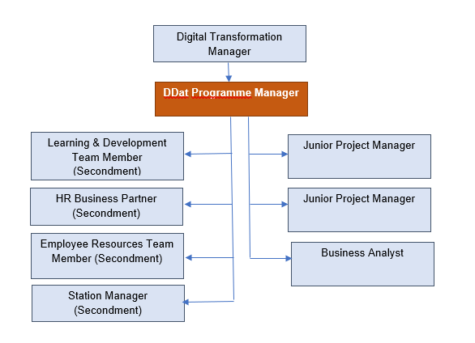

Main duties and responsibilities of the role.
- Lead the development and execution of programme strategies, ensuring programmes meet organisational goals and are delivered on time, within budget, and scope.
- Manage stakeholder engagement and change initiatives to support the adoption of new technologies, while maintaining clear communication throughout.
- Oversee governance structures, risk management, and ensure compliance with data protection, cyber security, and procurement regulations.
- Handle resource planning and budget control, ensuring value for money and supporting the creation of business cases and investment proposals.
- Provide leadership and development for programme teams, fostering a culture of collaboration, innovation, and continuous improvement.
- Drive innovation by monitoring emerging technologies, evaluating programme outcomes, and leading post-implementation reviews.

Organisational wide responsibilities.
- Adherence to the NFCC Core Code of Ethics and West Yorkshire Fire Service Values.
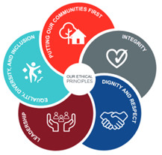
- To implement and promote the Authority’s:
- Health and Safety policies.
- Equality and Diversity policies.
- Information Security Management System policies.
- Safeguarding policies.
- Business continuity policy and contingency arrangements.
- Policies related to General Data Protection Regulation and Data Protection Act 2018.
- Commitment to maintaining our Customer Service expectations.
- A satisfactory standard Disclosure and Barring check is required for the role.
- This post has been designated a hybrid working post which means the postholder’s working time will be split between the workplace and home. The actual pattern and number of days at each will be agreed locally with the line manager and will be determined based on the service needs.

Skills and experience requirements for this role
In the supporting statement section of the application form give clear, concise examples of how you meet all of the Essential person specification criteria (i.e. items you must be able to do from day one to be able to do the job), identified as ‘Application’ in order to be shortlisted for this vacancy. If a large number of applications are received, only those who also meet the Desirable criteria, identified as ‘Application’, will be shortlisted, i.e. criteria you need to do the job, but which could be learnt during training.
Please list or number the competency criteria below against which you are providing evidence/examples in order to structure your supporting statement in a well organised way.
There may be some criteria that are identified through ‘Selection Process’ only. You will only be assessed on these criteria during the selection process and not from your application form, this may involve tests, presentations, interview etc.
 | Experience. | Essential/Desirable. | Where identified.
 | Substantial experience in leading complex digital transformation programmes. | Essential. | Application & Selection Process.
 | Proven track record of managing multi-disciplinary teams and large budgets. | Essential. | Application & Selection Process.
 | Experience of stakeholder engagement and cross-functional collaboration. | Essential. | Application & Selection Process.
 | Experience of managing external suppliers and contracts. | Essential. | Application.
 | Experience of working in a senior digital role within a public sector organisation. | Desirable. | Application.

 | Education and Training. | Essential/Desirable. | Where identified.
 | Degree or equivalent experience in a relevant discipline. | Essential. | Application.
 | MSP Practitioner or equivalent experience. | Essential. | Application.
 | Certifications in Agile methodologies or equivalent experience. | Essential. | Application.
 | Knowledge of digital service standards and emerging technologies. | Desirable. | Application.

 | Special knowledge and skills. | Essential/Desirable. | Where identified.
 | In-depth understanding of digital technologies (e.g. cloud, AI, IoT, data analytics). | Essential. | Application & Selection Process.
 | Knowledge of people orientated processes, procedures and legislation. | Desirable. | Application & Selection Process.
 | Strong analytical and strategic thinking skills. | Essential. | Application & Selection Process.
 | Excellent communication and influencing skills. | Essential. | Application & Selection Process.
 | Ability to manage competing priorities and deliver under pressure. | Essential. | Application & Selection Process.
 | Proficiency in project management tools (e.g. Jira, Asana, MS Project, DevOps). | Essential. | Application & Selection Process.

Job Description last updated: October 2025

