West Yorkshire Fire & Rescue Service
  - Job Description.
Post Title: Data Quality Administrator.
Grade: 4.
Responsible To: Digital Data Quality Manager.
Purpose Of Post: As a Data Quality Administrator, you will play a crucial role in ensuring the accuracy, integrity and reliability of our organisation's data. You will be responsible for developing and implementing data quality standards, conducting regular data audits and collaborating with various departments to address data quality issues. Your expertise will help drive informed decision-making and support the overall success of our data management initiatives.

Organisational chart.

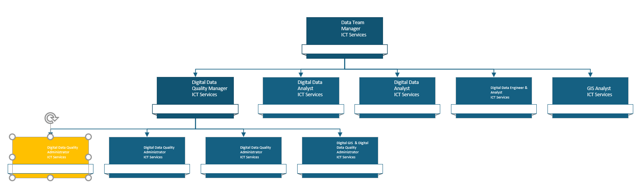Main duties and responsibilities of the role.
- Monitor, assess and improve data quality amongst multiple systems and databases.
- Develop and maintain data quality dashboards and reports including generating and creating any necessary reports from data systems as required.
- Collaborate with data owners to ensure data accuracy and compliance with data quality standards.
- Support data cleansing, inconsistencies or gaps and work with relevant teams to resolve issues.
- Provide training and support to users.

Organisational wide responsibilities.
- Adherence to the NFCC Core Code of Ethics and West Yorkshire Fire Service Values.

- To implement and promote the Authority’s:
- Health and Safety policies.
- Equality and Diversity policies.
- Information Security Management System policies.
- Safeguarding policies.
- Business continuity policy and contingency arrangements.
- Policies related to General Data Protection Regulation and Data Protection Act 2018.
- Commitment to maintaining our Customer Service expectations.
- A satisfactory standard Disclosure and Barring check is required for the role.
- This post has been designated a hybrid working post which means the postholder’s working time will be split between the workplace and home. The actual pattern and number of days at each will be agreed locally with the line manager and will be determined based on the service needs.

Skills and experience requirements for this role
In the supporting statement section of the application form give clear, concise examples of how you meet all of the Essential person specification criteria (i.e. items you must be able to do from day one to be able to do the job), identified as ‘Application’ in order to be shortlisted for this vacancy. If a large number of applications are received, only those who also meet the Desirable criteria, identified as ‘Application’, will be shortlisted, i.e. criteria you need to do the job, but which could be learnt during training.
Please list or number the competency criteria below against which you are providing evidence/examples in order to structure your supporting statement in a well organised way.
There may be some criteria that are identified through ‘Selection Process’ only. You will only be assessed on these criteria during the selection process and not from your application form, this may involve tests, presentations, interview etc.
 | Experience. | Essential/Desirable. | Where identified.
 | Demonstrable knowledge/experience of data regulations (e.g. GDPR). | Essential. | Application & Selection Process.
 | Experience of using data within systems and databases. | Essential. | Application & Selection Process.
 | Experience of using Microsoft 365 applications such Excel. | Essential. | Application & Selection Process.

 | Education and Training. | Essential/Desirable. | Where identified.
 | Literacy and Numeracy at Level 2 / GCSE Maths and English Grade C/4 or above / equivalent qualifications, or equivalent level of literacy and numeracy gained through work experience. | Essential. | Application.
 | ITIL Foundation or willingness to work towards this. | Desirable. | Application.
 | Level 3 or above qualification in data or willingness to work towards this. | Desirable. | Application.

 | Special knowledge and skills. | Essential/Desirable. | Where identified.
 | Solves data issues efficiently using analytical thinking to identify and resolve inconsistencies. | Essential. | Application & Selection Process.
 | Maintains high data accuracy through careful validation and attention to detail. | Essential. | Application & Selection Process.
 | Communicates clearly and collaborates well with both technical and non-technical teams. | Essential. | Application & Selection Process.
 | Demonstrate commitment to good data quality within all areas of work. | Essential. | Selection Process only.
 | Demonstrate commitment to and understanding of Equality & Diversity, NFCC Core Code of Ethics and WYFRS values. | Essential. | Selection Process only.

Job Description last updated: June 2025

